SPECIAL GUARDIANSHIP ORDER SUPPORT PLAN
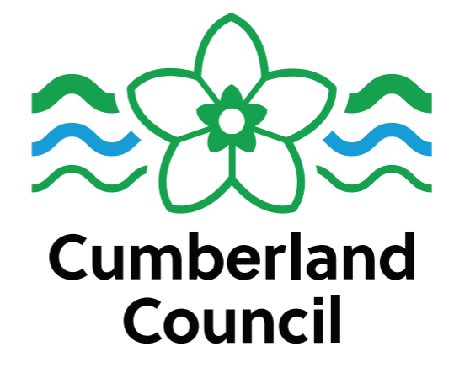
Special guardians have "overriding" parental responsibility, meaning they can make day to day decisions without consulting the parents, however consent from parents (or the court) is needed for major decisions like:
  - Changing the child's surname.
  - Taking the child out of the UK for more than three months.
  - Consenting to the child's adoption.
  - Non-health related surgery.
Please check with the Kinship Care team if you are unsure.

Child’s Name: Date of Birth: Special Guardians Names:

What need has been identified? | How will this be met? | Who will be responsible for  meeting the need? | Start Date | Review Date
Physical health inc future risks

Emotional and behavioural  Adoption and Special Guardianship support fund. | Children who are subject to SGO or CAO, who were previously subject to a care order are eligible to access this fund. There is a fair access limit of £3000 per child for assessment and / or therapy which is confirmed for the year 2025 /26. This may change in future years. The link to the Government Guidance is https://www.gov.uk/guidance/adoption-support-fund-asf)
Education including support from virtual school | EHCP  Pupil Premium  The virtual School provides advice and information to support children who have been previously looked after; further information can be found at: https://cumbria.gov.uk/childrensservices/schoolsandlearning/virtualschool/previouslycla/default.asp  Alternatively contact Ed Strong (responsibility for supporting previously looked after children)  Contact Ed at Edward.strong@cumbria.gov.uk or call on 07827982322
Family and other important relationships including siblings

Family time arrangements

Financial support | If your financial circumstances change, you must notify the kinship team straight away to ensure you are receiving the correct allowances. You must tell us if the child is no longer in your care.
Support services  Family Action PAC UK  Kinship Charity | Family Action PAC UK.  Special Guardians are encouraged to register with the website, where they will have access to resources, support groups and training.  PAC-UK National Advice Line: 0300 1800 090 This is a free and confidential service which is staffed by social workers and therapists experienced in trauma informed care. They are able to give specific advice on a range of issues. PAC UK do not share information with the local authority unless someone is at risk of harm.  Open: Mon, Tue and Fri 10am – 4pm, Wed and Thu 10am – 7.30pm (except bank holidays)  Email: advice@pacuk.org.  Website: www.specialguardiansupport.org.uk  Kinship is a national charity which offers free training and advice, which is government funded.  https://kinship.org.uk/support-and-advice/training-and-events
Support from Kinship care team | The kinship service provides informal coffee and chat support groups across Cumbria. The Special Guardians will need to contact the kinship team for details if they would like to access these.  The Kinship team provides online support groups and training – the Special Guardians will need to consent to be added to the mailing list to access these and receive up to date information. SGOsupport@cumbria.gov.uk  The kinship team can give advice and signpost special guardians to training and support, on an individualised basis. The team will also review SGO support plans. A letter will be included in the annual financial review paperwork to confirm if a support plan review is requested.
Criminal injuries compensation if applicable

Safeguarding | If the Special Guardians become unable to care for [the child] or seek to transfer their care to another person, including either parent, they must first contact the local authority so that risk assessments can be undertaken to ensure that the child is safe.
Leaving Care Services

Any other identified needs

Social Worker

Senior Manager

Kinship care team manager

