

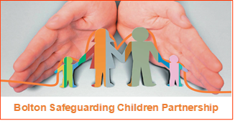

Missing Children and Young People Protocol

This document sets out the strategic and operational responses by the Local Authority and partner agencies for children and young people who go missing, as well as offering advice and guidance for practitioners in this area of practice.

March 2025

Contents

Background 3

Prevalence 4

Principles 4

Terms 5

Reasons why children go missing 6

Bolton Missing Service 7

Bolton response to children who go missing and return 9

Actioning individual missing responses 10

Specific Situations 12

Return Interviews 13

Strategy Discussions 15

Escalation and Senior Manager Alerts 16

Sharing Intelligence 17

Monitoring and reporting 18

Appendices

Right Care Right Person 20

Guidance for Schools 22

Children Looked After guidance 26

Return interview template 28

Partnership Information Sharing Form 30

National alert notification form 34

Trigger plan 36

Background

In Bolton, we want to give all our children the best possible start in life, so that they have every chance to succeed, be safe and happy. This document applies to all children and young people who live in Bolton or are cared for by Bolton who go missing from their home, whether that be living with parents or accommodated by the Local Authority.

When a child goes missing or runs away from home or care setting, they are at risk and therefore this is a safeguarding issue. When missing, children and young people are either seeking to escape from a problem such as neglect or abuse at home, or to go somewhere they want to be. They may have been coerced to go missing by someone else, who may be seeking to exploit them.

Whatever the reason, all children and young people who go missing are at risk of harm. When missing, children may experience physical abuse, emotional abuse, sexual abuse and/or be exposed to exploitation. They may feel scared and lonely and/or be placed in a position where they are taking risks or self-harming. They may also find themselves in dangerous situations, such as having to sleep rough or forced to commit crimes. Family and social relationships may suffer, education may be affected, and life chances may be adversely affected. Missing children are vulnerable to trafficking, exploitation, violent crime, drug and alcohol misuse, or involvement in other crime.

A child or young person who goes missing just once faces the same immediate risks as those faced by a child or young person who regularly goes missing. However, children who go missing when they are young, and/or more frequently, are more likely to face adverse experiences that can impact on their wellbeing.

Bolton’s partners recognise that there are opportunities to work together. Our joint aim is to reduce incidences of children going missing. Each missing episode is potentially serious. The reasons for running away are often varied and complex and cannot be viewed in isolation from home circumstances or their experiences of care. Proportionate attention from all professionals involved should be given to every missing episode, ensuring a consistent and coherent response is given both to locate the child or young people and on their return to where they live.

It is important that the multiagency partnership develops an understanding of missing episodes that is informed through data collection and analysis of children’s own experiences via return interviews. It will use the information to:
- ensure processes are robust.
- develop practice through learning and development opportunities.
- inform commissioning of relevant services.

This protocol sets out our approach to children and young who are missing. Following clear processes, underpinned by sound principles of practice, we will ensure that as a partnership we quickly identify missing children, respond robustly and comply with statutory and local guidance.

The document is written in accordance with the ‘DfE Statutory Guidance on Children who Run Away or go Missing from Home or Care, 2014’ and the ‘Greater Manchester runaway and missing from home and care protocol (RMFHC).

Greater Manchester Runaway and Missing from Home and Care... (trixonline.co.uk)

Prevalence
In 2023/24, there were:
- 1951 missing episodes.
- For 612 individual children and young people.
Of those:
- 47% of children and young people were not open to social care at the time of the missing episode.
- 26% were looked after children.
- 5% went missing 11 times or more.
- 5% of children were aged 10 or under.

Principles

As a partnership, we agree these principles to guide our practice:

- The safety and welfare of the child is paramount.
- Child protection procedures will be considered for all children or young people where significant harm has been identified though a missing episode.
- We will seek to build positive trusted working relationships with children.
- We will listen to children and hear their voice as an essential aspect of understanding what is happening for them.
- We will prioritise the physical and mental health of children, ensuring access to appropriate support services for those affected by missing episodes.
- Every missing child will be offered and encouraged to be interviewed by someone other than their direct carer when they return home.
- Data will be used effectively to monitor and track those children who may require the highest level of safeguarding; utilising return interviews and analysis to better understand the needs of children and young people who go missing and to plan effectively for them.
- As a partnership we will work together to ensure consistent and robust information sharing and pooling of resources to provide support to children and young people who are or have been missing.

All agencies and individual practitioners should be guided by what young people want from the services around them when they go missing and this should inform service development and practice:

- Young people want carers, social workers, and the police to avoid making assumptions about them and why they might have gone missing. These professionals should try to understand their reasons, acknowledging that every child is different and will be facing different challenges.
- It is not inevitable that young people will go missing. Carers should genuinely attempt to mitigate any issues that may cause a young person to go missing. This should include building positive relationships with the young people in their care and getting to know them. This can also help to inform decision making if the child is not where they are supposed to be.
- Young people do not want the police to automatically be contacted if they are not where they are supposed to be. They want decisions around contacting the police to be made based on their own unique situation, including any risks and the circumstances at that time. The police should not be contacted as a disciplinary measure. However, it is vital that they are contacted when a child is at risk of coming to harm.
- When the police do have contact with a missing young person, they should act supportively and respectfully towards them using a child-centred policing approach that is trauma-informed.
- Professionals should try to understand the unique challenges facing looked after children, including the conflict in wanting to be treated like other children but also needing their often complicated circumstances to be taken into account.

(Childrens_views_on_being_reported_missing_from_care.pdf (missingpeople.org.uk)

Terms:
For this protocol, the following definitions apply and reflect the definitions set out in statutory guidance:

Child - anyone who has not yet reached their 18th birthday. ‘Children’ therefore means ‘children and young people’ throughout this procedure.

Missing - a child whose whereabouts cannot be established and where the circumstances are out of character, or the context suggests the person may be subject of crime or at risk of harm to themselves or another.

Absent - a child not at a place where they are expected or required to be.

Missing from care - a looked after child who is not at their placement or the place they are expected to be and their whereabouts is not known. Children placed out of borough must receive a consistent and robust service equal to those living in Bolton.

Away from placement without authorisation - a looked after child whose whereabouts is known but who is not at the place they are expected to be, and the carer has concerns or the incident has been notified to the local authority or the police.
While they are not missing, they may still be placing themselves at risk because of where they are. For example, they may choose to stay at the house of friends where the carer has concerns about of risks of exploitation. The police will not consider this child as missing or absent, but the procedure describes the appropriate course of action to protect the child.

COLA- A child looked after by another local authority who goes missing in the placement authority.

CLA-OOB: A child looked after by Bolton, but in a placement out of borough.

Reasons why children go missing

We already recognise that there are several ‘push’ and ‘pull’ factors that may impact on a child, leading them to leave a situation or go somewhere they want to be. These include –

Push factors:

- Problems at home; including long-term abuse or maltreatment or living in neglectful situations.
- Family break-up or parental conflict.
- Mental and emotional health issues – a disproportionate number of young people who go missing mental health issues.
- Problems at school - including relationships with teachers or other pupils or ceasing to attend due to exclusion or withdrawal by parent or removal from roll with no named destination.
- Bullying – children who are being bullied are more likely to go missing.

Pull factors:

- Wanting to be near friends or family – especially when a child is in care and there are problems in family time arrangements with family and friends.
- Grooming for potential exploitation or child trafficking – a child may be coerced to go missing by someone who has power or control over them and seeks to exploit them either sexually or criminally.
- Criminality - this includes the enticement of material gain as well as threats to themselves or family members.
- Stage of Development – this can include a young person’s desire for autonomy, or a lack of understanding of risk/awareness of consequences.

Bolton Missing Service
We ensure that all children who go missing are supported through a ‘child first’ partnership approach. This ensures children who go missing receive a consistent response that takes their lived experience into account. This can be tracked through information sharing, reporting and auditing, which provides an opportunity for a response to individual circumstances but also a strategic overview to inform practice improvement.

Stakeholders include:

Greater Manchester Police
The main functions include:
- Respond to and record missing reports from professionals and public.
- Undertake actions to locate and return children where necessary.
- Share information with relevant partners, including Health and Education through the Encompass process.
- Complete safe and well checks.
- Submit care plans where concerns are identified.
- Track locations and associates for ‘hotspots’ and to identify risk of exploitation.
- Attend strategy discussions for individual children.
- Produce data reports, including the identification of the most at risk children.

Health
For young people living within Bolton the health contribution is as follows:
- All missing from home episodes are sent to the 0-19 hub and are reviewed by the duty practitioner.
- The duty 0-19 nurse will review the records and liaise with relevant partners to establish if there are unmet health need. If there are none found, this will be documented, and no further action taken. If there are unmet health needs, school nurse will either signpost or address as appropriate.
- Duty practitioners will attend strategy discussions, and any actions will be followed up by the allocated school nurse.
- There is a health practitioner within the Integrated Front Door, who attends the daily risk meeting. Health also contribute to wider meetings including the Child Exploitation Action Meeting, and specific health support is provided to adolescents through Parallel.

If a young person is placed out of area, the health response is provided by the local area in which the young person lives.

If a young person is open to CAMHs, then GMMH should be invited to meetings in their own right.

Education
- Receive reports via Encompass where police share a care plan.
- Attend strategy discussions.
- Liaison with other professionals who may be involved with the child’s care will take place if appropriate.

Bolton Council

Missing and Information Sharing Coordinator:
- Record daily information on social care system, including alerts to allocated early help lead professionals, social workers, team managers and Independent Reviewing Officers.
- Triage information relating to children going missing and refer appropriately.
- Attend strategy discussions for individual children.
- Support and commission service providers to conduct Independent Return Interviews.
- Oversee compliance with this protocol by providers, partners and social care staff, challenging deficits in practice where necessary.
- Provide advice regarding compliance with Statutory Guidance and GM Protocol (RMFHC).
- Provide information, briefings, presentations, and analysis to assist partner awareness of missing issues.
- Produce reports and data to be available for scrutiny across the Department.
- Complete audits as part of quality assurance to ensure return interviews are of good quality.

Social care and early help:
- The Integrated Front Door will act on referrals received.
- When a child has a named practitioner in early help or social care, those practitioners will receive missing alerts and will be expected to act upon them by following the detailed guidance in this document.
- Independent Reviewing Officers will be notified of missing episodes to ensure they can review action taken in response.

Out of hours Emergency Duty Team (EDT)
- Record a case note if a child is reported missing out of hours.
- Copy an alert to the child’s social worker and team tray and the Missing and Information Sharing Coordinator.
- Notify senior managers via the on-call process where required.
- Provide information to police from the child’s file to support them whilst missing out of hours.

Complex Safeguarding Team (CST):
- Ensure that operational joint work practices optimise the opportunities to safeguard and support children who go missing, where there is evidence exploitation is occurring or a strong professional suspicion of exploitation.
- Scan police systems for information related to exploitation.
- Scrutinise missing reports to identify risk of exploitation.
- Hold a daily governance meeting to discuss and allocate work and share information with partners.
- Use data and qualitative information to profile and map, identifying risks to individual children and links to potential exploiters.
- Attend and support strategy discussions.
- Be responsible for identifying and making appropriate NRM (National Referral Mechanism) referrals.

Independent Return Interview service
This is currently provided by RUNA (Urban Outreach).
- RUNA conduct independent return interviews find out what happened from the child’s perspective, and to understand their lived experience.
- They discuss the risks and dangers of being missing, promote self-reflection and seek to address the issues which may cause young people to go missing.
- RUNA support the young person and their family to minimise future risks through safety planning.
- They refer to partner services and collaborate in multi-agency action plans for children at risk of harm and exploitation.
- RUNA share information with relevant agencies, including police.
- Return interviews are offered, and aim to be completed, within 72 hours of the child returning home.
- All return interviews are sent to the Missing and Information Sharing Coordinator.

Carers and placements
The Philomena Protocol is a scheme that asks carers to identify children and young people who are at risk of going missing, and to record vital information about them that can be used to help find them quickly and safely.

It is an expectation of all placements that a Philomena protocol form is kept up to date and stored safely but accessible to staff members working at the time if a child should go missing. For further guidance please read Philomena Protocol | Greater Manchester Police (gmp.police.uk)

Bolton response to children who go missing and return

Weekday notification activity:
- Police provide a list of missing and returned children every weekday morning to mfh@bolton.gov.uk, RUNA and the Complex Safeguarding Team.
- Placements for CLA-OOB send overnight missing or ‘away from placement without authorisation’ notifications to mfh@bolton.gov.uk.

Missing and Information Sharing Coordinator:
- Opens a missing/away from placement without authorisation episode for each child on LCS systems. This automatically notifies the Social Worker, Team Manager and Independent Reviewing Officer.
- Alerts social workers, team managers and IROs if a child requires a missing strategy discussion.
- Shares information if information identifies associates/locations of interest.
- Informs RUNA of any missing reports for CLA-OOB children with request for them to schedule telephone return interviews.
- Informs home authority of COLA children reports.

RUNA
- Schedule, offer and complete return interviews (RIs) for all Bolton children who are recorded as missing and have returned, regardless of whether the child is open to services or not.
- Complete safety planning with child and parent.
- Share completed Return Interviews with Missing and Information Sharing Coordinator.
- Share intelligence where relevant with police.

Complex Safeguarding Team
- Scan systems for Daily Governance meeting.

Actioning individual missing response

Police
- Record and risk assess each missing episode.
- Deploy resources to locate children when high risk or reasonable enquiries have been made.
- When found, police may return children home or to a safe place.
- Police complete safe and well checks and submit care plans for additional support, where necessary, to social care and early help services. They also share care plans with the child’s school and with the 0 – 19 Health Service.

Under GMP’s Right Care Right Person scheme, high risk will be the default risk setting for:
- All children aged 13 or under.
- All children identified as being at risk of sexual or criminal exploitation.

Children under 18 should not be categorised as low risk.

If an episode is deemed as high risk, then there will be GMP deployment to locate the child or young person. If an episode is deemed as medium risk, the caller will be asked to undertake reasonable enquiries prior to police deployment.

Complex Safeguarding Team
- Allocate daily tasks for children on their caseload who have been missing. Where children are repeat missing and there are concerns about exploitation, police and the Complex Safeguarding Team will create trigger plans for children.

Local Authority Missing and Information Coordinator
- Child not known or open to services – the Missing and Information Sharing Coordinator screens missing reports and missing care plans.
- Where required, a consultation with IFD is held to further assess whether early help could support or a referral to social care is required. Referrals are then made. A referral is automatically made when a child meets the criteria for a missing strategy discussion.
- Child open to Early Help – the Missing and Information Sharing Coordinator will alert the Lead Professional, who will screen the missing report to consider next steps. This may lead to a review of the existing plan or a referral to social care or other services.
- Child open to social care (child in need, child protection, looked after) – an alert is sent via LCS to the social worker, team manager and IRO, who will review missing information and amend/adjust plans appropriately. If a child has an allocated social worker, they will complete a Missing Risk Assessment and Trigger plan. For looked after children, Care/Pathway plans must be updated to reflect missing from home episodes and include strategies to minimise future risks.
- Initial screening by the Missing and Information Sharing Coordinator may indicate that there are no contextual concerns. Consent will be sought from parents by RUNA to offer a return interview to the child. The missing report will only be closed on receipt of return interview where no concerns are raised or if a Return Interview is declined by parents. RUNA may signpost or refer to partnership services as part of the return interview.

A small number of reports will result in children and young people not having a missing episode recorded. These include:
  - Children who are reported missing but are with a parent with parental responsibility.
  - Child absconds from a hospital ward but stays on hospital premises and is located there.
  - Child is located in Bolton but is not resident in the borough. In these circumstances, the Missing and Information Sharing Coordinator will inform the home/responsible Local Authority.

CLA-OOB – child is missing from a placement out of borough
- The placement plan meeting will agree and record triggers that might lead to a child going missing, when the child must be reported missing by the placement, what the responsibilities of the placement would be in locating the child and outlining who will undertake the return interview.
- As well as the social worker and EDT being informed, a notification must be sent to mfh@bolton.gov.uk by placements when a child is reported missing and when they return.
- The LAC health team in the relevant area should be made aware of missing episodes and included in any communication and meetings. Where children are deemed high risk the Named Nurse in Bolton should be made aware to ensure full oversight of health needs.
- On receipt of the missing report, the Missing and Information Sharing Coordinator will record the missing episode on the system and inform RUNA, who will offer a return interview unless this has been agreed differently in the placement plan.

COLA child placed in Bolton
- The Missing and Information Sharing Coordinator will inform the responsible Local Authority, who maintains responsibility for completion of the return interview and the sharing of information with relevant professionals supporting that child.

Away from placement without authorisation
- Residential staff or foster carers should be in regular contact with the child and visit them to try and encourage them back home.
- Placements will inform mfh@bolton.gov.uk when a child’s whereabouts are known but not agreed, and they are satisfied that their welfare isn’t compromised. These children will not be reported missing, but the Missing and Information Sharing Coordinator will record as ‘away from placement without authorisation’. Alerts are sent to social workers and team managers. Social workers will review and safety plan with young person and explore whether the address can be authorised. In some cases, the social worker, young person and placement can pre-agree authorised places that they can go to and how often.
- Should a young person have multiple ‘Away from placement without authorisation’ events, this should be reviewed as part of care planning meetings to review patterns and themes. This will ensure that the young person is using the placement effectively and risks continue to be managed. If there are 6 episodes in a 28 day period, this should trigger a review care planning meeting or strategy discussion if the risk deems it necessary. This will be chaired by the team manager.

Specific Situations

Requesting police assistance to return a child to placement, or an absent child
Although the Police may not always identify children/young people as ‘missing’ or away from placement without authorisation under their procedures, occasions may arise when assistance from the Police may be required to remove a child/young person from where they are staying, if they are felt to be significant harm. Liaising with the police is important to determine the risk to the child/young person. The Team Manager will keep the situation under review and will consult with the head of service as to when a request for Police assistance should be made. This will not be dependent on length of time away from placement but rather the risk the absence represents.

Missing Children who may also be ‘Wanted’
There will be occasions when a child may be reported as missing who may also be wanted in relation to:
- their suspected involvement in a criminal investigation
- an outstanding warrant or other matter issued by a court.
- having absconded from lawful custody/care
- having entered the country without appropriate authority (see immigration cases)

If a decision is taken to treat a child as ‘wanted’, a missing report will still be recorded. The usual procedures will apply in respect of seeking to locate the child.

National alerts
When a national alert is received from another authority, this should be sent to the Missing and Information Sharing Coordinator. They will:
- Share with Health and Maternity - boh-tr.BoltonChildProtection@nhs.net maternitysafeguarding@boltonft.nhs.uk.
- Check local systems for any information about the missing person(s) – if yes: inform the referrer and alert the social worker in Bolton.
- Record on National Alert spreadsheet on Share Point, which can be accessed by EDT.
- Keep the record for 3 months.

Following a strategy discussion, should there be concerns that a family have moved to another area, and it is agreed that a national alert should be sent from Bolton, the following steps should be taken:
- Team Manager completes national alert form, and sends to the Lead Administrator at boltonsafeguardingchildren@bolton.gov.uk.
- The Lead Administrator will send to the National alerts distribution list (kept in Partnership ‘Contacts’ folder) and sends a copy to mfh@bolton.gov.uk.
- Social worker records form and adds a case note to system.
- Missing and Information Sharing Coordinator adds to National Alert spreadsheet.
- Lead Administrator reviews and maintains distribution list twice a year.

Return Interviews
A Return Interview can provide an opportunity for the young person to say what happened in their own words. It should be completed by an independent person, not directly involved in their care. For children living in Bolton, all return interviews will be offered in person.

The return interview is important in safeguarding the child or young person in the future, including providing information of how to prevent future missing episodes. It must not be viewed as a routine or administrative task but as an opportunity to inform case planning, take account of the child’s views and inform wider strategic planning.

The purpose of hearing from the child is to:
- Help understand and address the reasons why a child has gone missing, such as abuse, neglect or exploitation, involvement in gangs or crime or use of alcohol or drugs.
- Identify harm that may have occurred while the child was away,
- Allow professionals to consider actions they need to take to address any harm and prevent further risks.

The following issues should be discussed with the young person sensitively. Any or all the issues could be relevant:

- What happened to make you go missing?
Were there ‘pushes’ from home/living relationships or circumstances? Were there ‘pulls’ from or to someone/something else? Peer pressure or trouble with friends or bullies? Issues with school? Drugs or alcohol issues? Influence from risky adults? Mental health or self-harm?

- What happened when you were missing?
How did you keep yourself safe, were you able to get in contact with a safe adult? Did anything harmful happen to you while you were away, or any near misses? Who were you with? (Adults or children?) If you had wanted to go home was anything or anyone stopping you? Did you have to do anything you didn’t want to in exchange for something or to keep yourself safe? Do you have any physical injuries or mental health issues that may need addressing?

- What happened when you returned?
When did you decide to return? Were you scared to come back? Did anyone try to stop you from coming back? How did you get back? What would stop you going away again? If there were problems that made you go missing, do these still exist? What support do you need now? Do you need advice, tests or other medical support?

Safety planning
All return interviews will include a safety plan, which will be developed with and for the young person, including:
- How can we stop you going missing again?
- If you go missing again, how can we make sure this is a bit safer?

Completed return interviews are sent to the Missing and Information Sharing Coordinator, who will review the information, upload it to the missing record and give advice if needed to the interviewer about sharing intelligence with police.

The return interview will be used to:
- Identify risk of harm that may not have been known at the point of the child returning and safe and well check being completed.
- Support information gathering and decision making at strategy discussions.
- Inform the need to refer or signpost for additional support to a family.

Lead professionals, social workers, CP Chairs and IROs should all ensure that they have read the return interview to be informed of the child’s views and identify possible actions to reduce further missing and prevent harm.

Strategy discussions
When children are missing regularly, it is important that all efforts are made to reduce missing episodes and related risk of harm. Strategy discussions must be held when one of the following is met:

- A child has 3 missing episodes in a 28-day period.
- A child has a single missing episode lasting 48 hours or more.
- Significant harm is identified in a single episode.

These are minimum requirements- where there are known high risk factors then an earlier strategy discussion should be convened.

The purpose of the meeting is to:
- Ensure all information relating to missing episodes is shared and risks assessed.
- Identify steps to find the child if still missing and/or to prevent the child/young person going missing in future.
- Identify the impact of going missing on the child/young person and other family members and agree if actions are needed.
- Decide whether Section 47 enquiries are required.

Chaired by Team Manager and organised by either the allocated social worker or a social worker from the Integrated Front Door, invites should be sent to health, education, any other services open to young person, the Missing and Information Sharing Coordinator, and police (request via bolton.publicprotection@gmp.police.uk, - they will allocate to the appropriate officer). Consideration should be given to inviting services involved with siblings if they are impacted by the circumstances of the missing episodes.

Those present at the meeting should share and discuss information relating to:
- Chronology of missing episodes.
- Push and pull factors leading to missing episodes.
- Locations when missing and where found (if known).
- Associates they were missing with – or friends they may go to.
- Risks of, or actual exploitation and/or trafficking.
- Any other specific risks to the child/young person when missing.
- Health concerns, including unmet neurodiversity or developmental needs or diagnoses, SALT and mental health concerns as well as any physical injuries which require medical attention.
- Education, including:
  - Participation.
  - Behaviours/social networks in education.
  - Learning development.
- Access to money/travel etc.
- Return interview arrangements.

The summary and action plan should analyse the information shared, threshold discussions and decisions should follow the Bolton Family Framework model, recording:
Red - elements requiring S47 enquiries
Amber - elements of concern
Green - strengths and support

For children missing 72 hours or more, consideration must be given to:
- National authorities’ notification.
- Press strategy.
- Photograph for release.
- Child Abduction Warning Notice.
- Legal services if there is any suspicion that the child may be removed from the UK

If a child continues to be missing for 72 hours, a follow up strategy discussion will be held. There should then be continued follow up strategy discussions every 5 working days as a minimum.

Should concerns continue then the fourth strategy discussion in relation to missing will be chaired by the Head of Service.

For colleagues in the Local Authority, there is now a dedicated proforma for missing strategy discussions, which includes guidance notes and a checklist of missing-specific questions and issues to consider.

Escalation/ Senior Management alerts
If a child has not been found after 48 hours, a strategy discussion will be convened to consider the risks to the child and what steps agencies can take to ensure the child is found as soon as possible.

Residential children’s homes also have a responsibility to report significant events to Ofsted and for missing children this is likely to be after 48 hours.

Within the Local Authority, the Missing and Information Sharing Coordinator will escalate via email the following situations to the Head of Service for Conferences, Reviews and Partnerships as well as the relevant Head of Service for the child (e.g. the Head of Service for Looked After Children if the child is looked after):
- When a child has not been found after 24 hours and they are looked after or subject to a child protection plan.
- Any missing episode of a child under 12 years of age.
- Any missing episode of a child with particular vulnerabilities, such as additional needs.

If a child has not been found after 72 hours, the Missing and Information Sharing Coordinator will complete a Senior Management Alert and this will be sent to the relevant Heads of Service as well as the Assistant Director for Children’s Social Care.

Other partners will have their own internal escalation guidance for children who go missing which should be referred to by practitioners in those agencies.

Sharing intelligence
The sharing of information is critical to developing a clear picture of local issues and wider community-related problems, which can inform police and partner actions to reduce threat, risk and harm.

Greater Manchester Police and the wider policing family is intelligence-driven, and relies heavily on intelligence from our communities, partners and law enforcement agencies, which, often without realisation, could provide crucial links where gaps in intelligence might exist.

An intelligence form is in use, where partners can share information gathered through return interviews or other professional contacts with missing children and their families. Information shared is strictly managed and the professional sharing details will not be incorporated in any subsequent intelligence reports.

Anything of immediate risk should be reported via 999 or 101 to the Police Control Room. This form does not replace the usual practice of making referrals to other services.

The Force Intelligence Bureau can be contacted at GMP 0161 856 6725, and completed forms should be sent to FIB@gmp.police.uk. A copy of the form is included in the appendices.

Mapping
Where intelligence highlights a particular group of young people who are going missing, and there are associations between them, then a mapping meeting should be held.

Mapping meetings should also be undertaken on a regular basis where intelligence highlights a specific issue or concern.

If children are open to multiple teams, the relevant team managers will agree who will lead on the meeting. The mapping meeting should include multiagency partners to ensure a triangulated approach. The meeting will use data and qualitative information to problem profile and map the scale of missing for individual children to ensure appropriate escalation and intervention.

The Missing and Information Sharing Coordinator will suggest the need for a mapping meeting at the strategy discussion in relevant situations and will contribute to the subsequent mapping meetings.

Mapping of young people, associates and hotspots may also take place at the multiagency Child Exploitation Action Meeting (CEAM).

Monitoring and reporting

Monitoring data and information gathering provides an account of the activity in respect of children who go missing. It offers the opportunity to scrutinise - identifying patterns, examples of good practice and potential gaps to check compliance with statutory and local guidance. It can inform strategic planning and be used to ensure continuous practice improvement.

Reports regarding missing children will be provided within the governance arrangements in place for each partner agency and Bolton’s Safeguarding Children Partnership.
- Dashboard – the daily ‘currently missing’ report will be reviewed by the Missing and Information Sharing Coordinator for action.
- Monthly report- provided by Information Analysis to Missing and Information Sharing Coordinator responsible Head of Service for Missing.
- Police produce a monthly report of high risk children.
- RUNA submit quarterly monitoring reports with data and case studies from return interviews.
- The Missing and Information Sharing Coordinator produces an annual report from which highlights are incorporated into Bolton Safeguarding Partnership Annual Report.
- Quarterly audits will be completed on the quality of return home interviews and safety plans as part of the departmental quality assurance framework.

Assurance
It will be important to review young people who have had a reported missing incident on three occasions or more in a 28-day period, children who have had a missing period of 48 hours or more and any other young people deemed to be ‘high risk’.

Alongside existing forums such as the Child Exploitation Action Meeting (CEAM), there should be an opportunity for partners to look and the context and outcomes for children who go missing to understand learning opportunities and the quality of response from agencies when children go missing.

Any themes or concerns will then be escalated to the Exploitation sub-group of the Bolton Safeguarding Children’s Partnership.

Appendices

- Right Care Right Person (RCRP) posters

- Guidance for Schools

- Partnership Information Sharing Form

- CLA protocol and notification form

- Return interview template

- Bolton Notification Alert form

- Senior Management Alert

- Police Trigger plan

Right Care Right Person (RCRP) posters
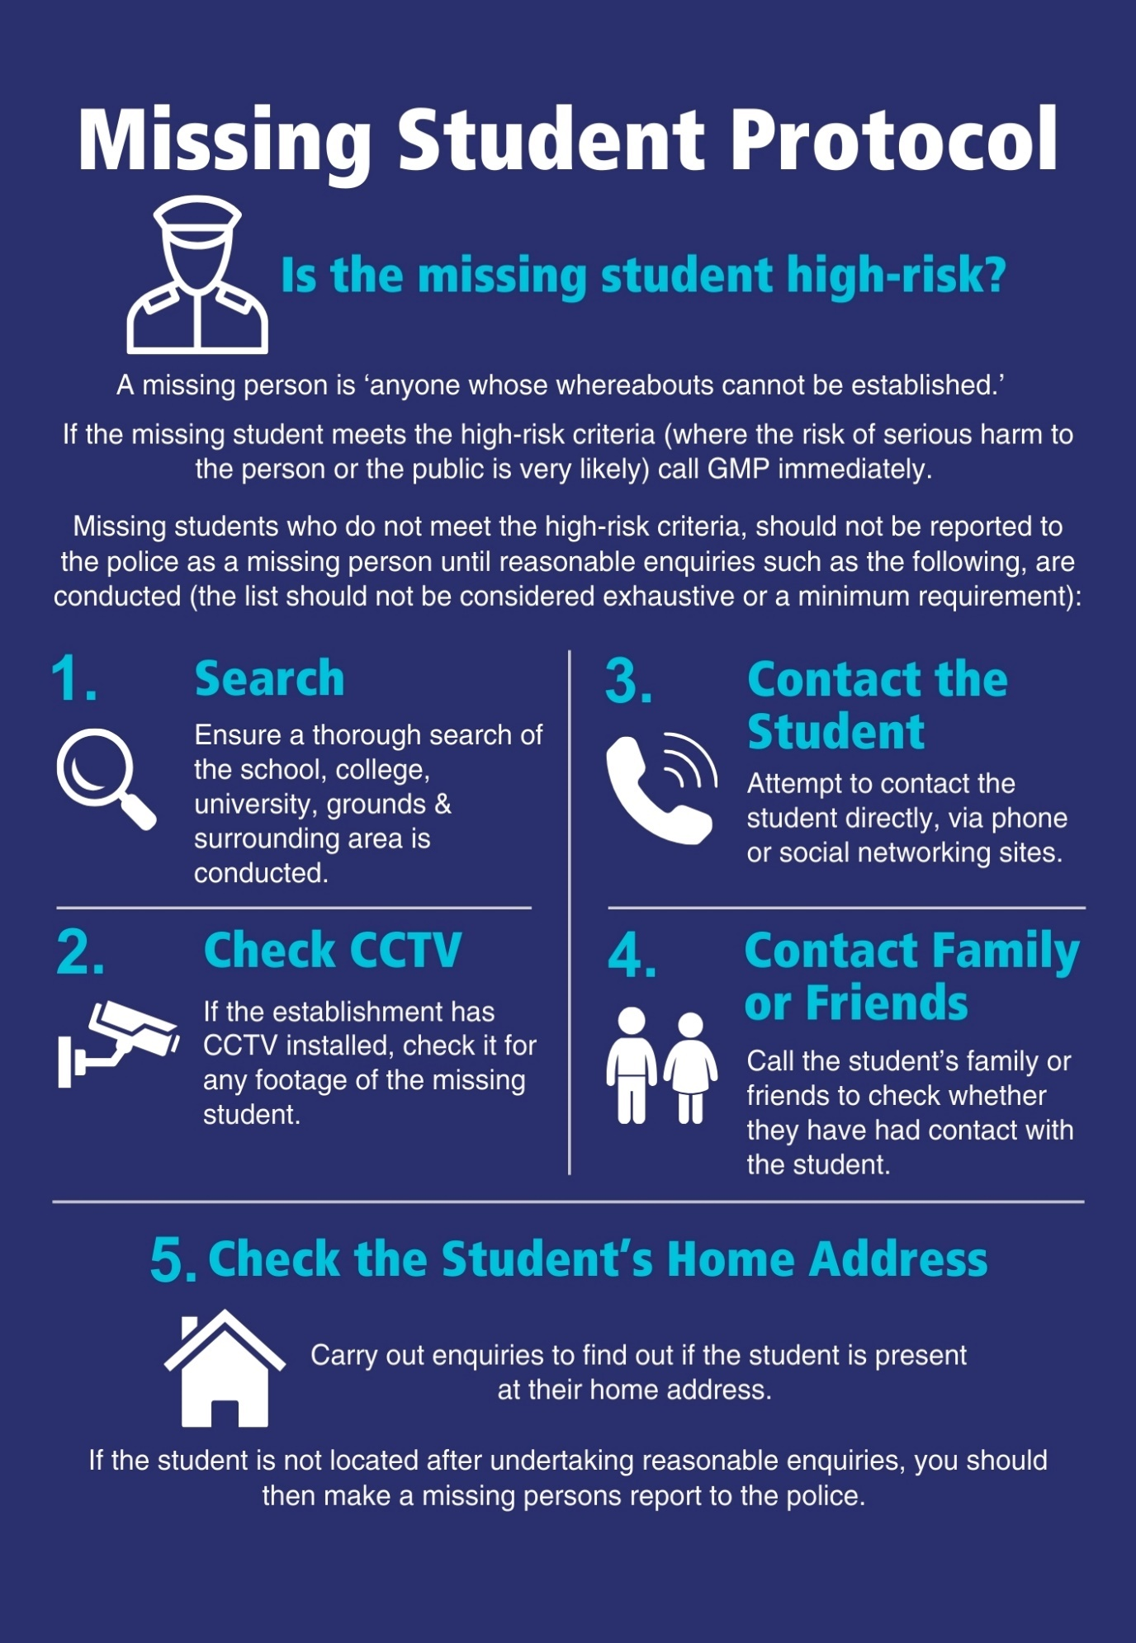

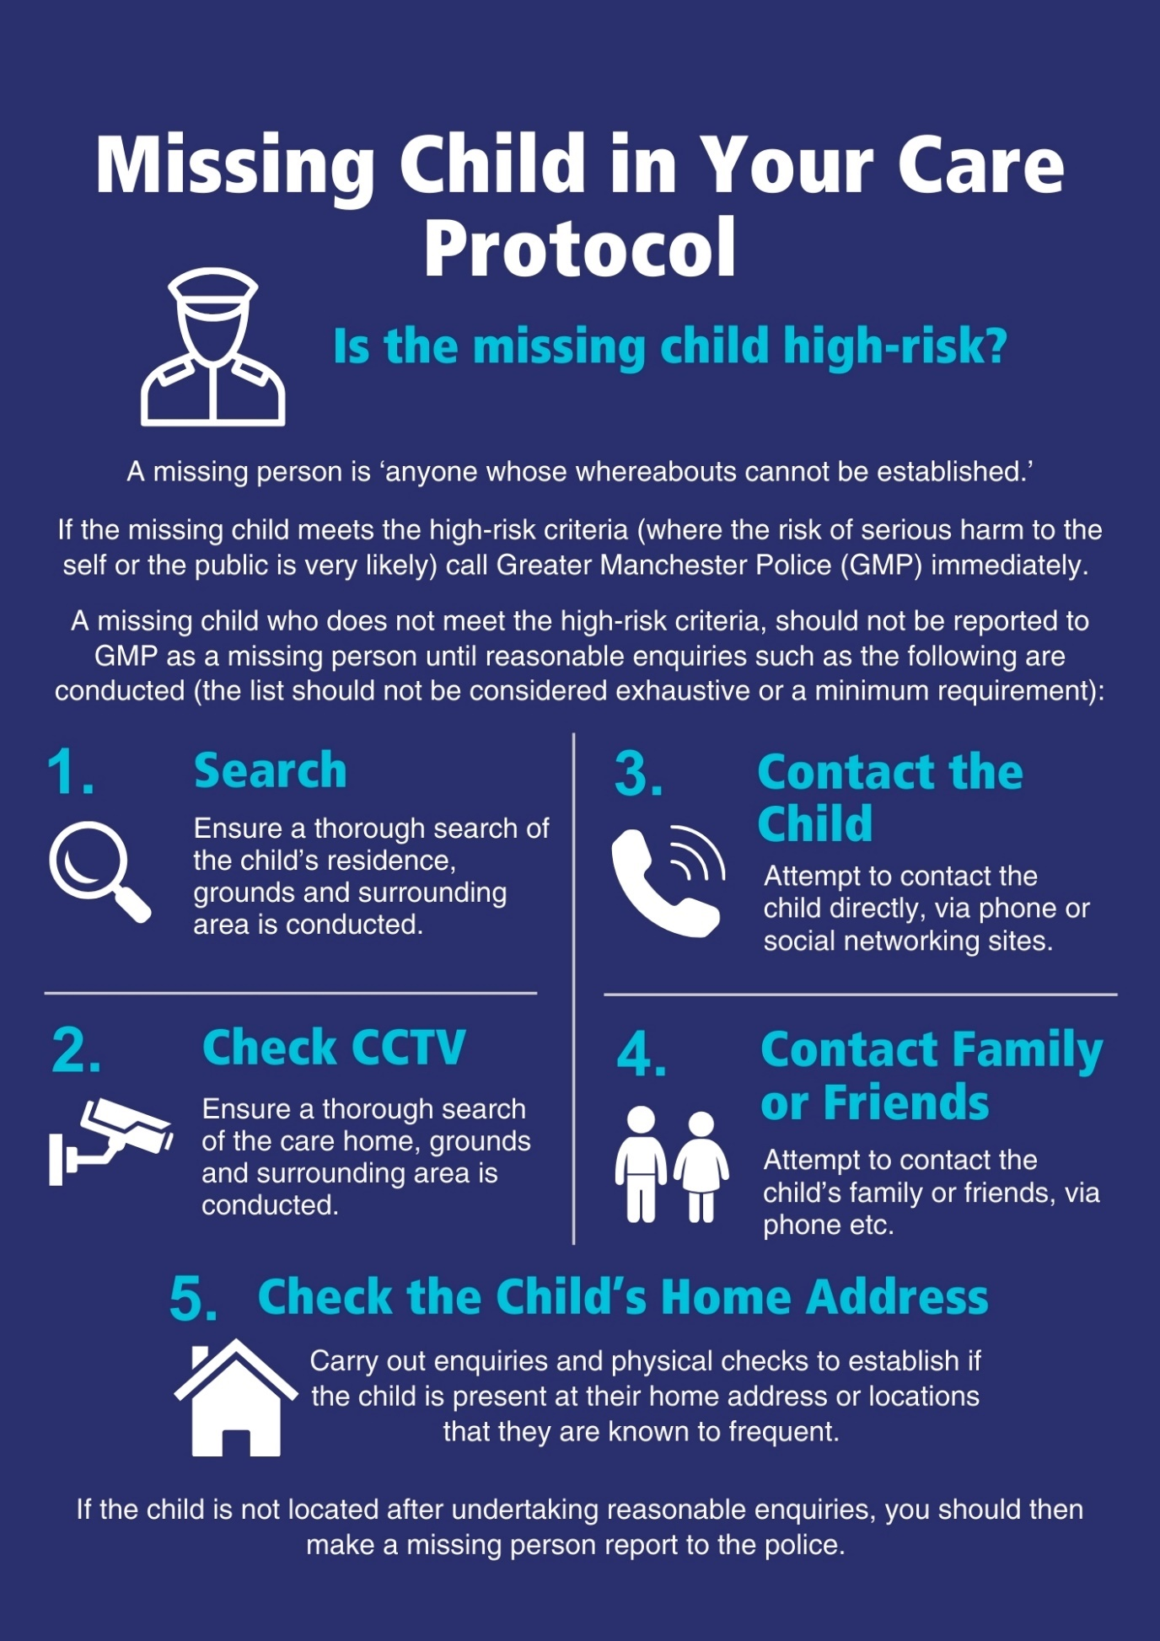

Guidance for Schools for dealing with circumstances where pupils are “missing” from school

Purpose
The purpose of this guidance is to set out procedures to support schools in dealing with instances where a pupil leaves school without permission to consider when they should be reported missing to police.

Context
Schools and other educational settings have a duty of care towards their pupils. This duty of care requires that all reasonable steps are taken to ensure that pupils are always safe and remain within the care of the school throughout the school day and during school led activities.
Schools will have clear rules and procedures about pupils leaving the school premises. Children should only be allowed to leave the school grounds during the school day with written parental permission, and if they are to be collected it must be by an adult known to the school. The school will have information on who this person is and their relationship to the child.
Schools will have accurate contact details in relation to all pupils and these should be regularly verified and updated.
This guidance does not cover Children Missing Education generally – it is for use when a child who is normally in school leaves the premises.

Child goes missing or leaves school
Where a pupil, present at registration, is subsequently found to be absent from school without authorisation, the procedures outlined in the Missing without Authorisation flow chart (below) should be followed.
An assessment of risk is required prior to consideration of police contact, schools should take account of each pupil`s individual circumstances, and considerations such as: age and vulnerability of the pupil; the prevailing weather conditions; the nature of the incident which led to the pupil absenting/leaving; the pupil’s previous history of being involved in episodes of absconding, and any other associated risks (such as LAC / CP/ CSE / CCE etc).
The Designated Safeguarding Lead should assess the risk of significant harm, based on up-to-date information. Only where there is an immediate risk of significant harm to the pupil or others should the police be contacted straight away via 999. Where there is no identified immediate risk of significant harm the relevant flow chart should be followed and any call to police should be via 101.
For preparation purposes please have appropriate information ready to give to police call handler when reporting.
Schools’ Risk Assessment
The level of risk for every missing pupil will depend on their individual circumstances and the assessment of this risk will determine at what point Police contact should be made, and by what means. In some situations, it will be appropriate for schools not to contact Police at all.
Wherever possible, the Risk Assessment should be undertaken by the school`s Designated Safeguarding Lead, and the considerations / information / rationale upon which it is based must be documented. Clearly the level of perceived risk can go up or down as enquiries to locate the missing pupil progress, so the initial assessment should be kept under review throughout the process. Once the incident is finalised, the Risk Assessment should be filed with the pupil`s Missing Plan.
In general terms, the level of risk should be identified as follows:
HIGH RISK would be identified where risk of SERIOUS harm to the pupil (or public) is assessed as being VERY LIKELY. (“Serious harm” being a risk which is life threatening and/or traumatic and from which recovery – physical or psychological – can be expected to be difficult or impossible).
MEDIUM RISK would be identified where risk of harm to the pupil (or public) is assessed as being LIKELY but NOT SERIOUS.
LOW RISK would be identified where risk of harm to the pupil (or public) is assessed as being POSSIBLE but MINIMAL.
Some examples of considerations to be considered when assessing risk are as follows, but this is not an exhaustive list and should therefore only be used as a guide since each child / situation will be different:
Physical Considerations:
- Age
- Vulnerability due to learning difficulties or additional needs; autism; other disability
- Medical issues – does they need medication; do they have it with them; can they self-medicate
- Mental health issues – do they suffer from depression; risk of self -harm; suicidal
- Risk of Child Sexual Exploitation; Child Criminal Exploitation / County Lines (“Trapped”)
- Risk of domestic abuse; child abuse (neglect, physical, emotional, sexual)
- Risk of honour-based violence; forced marriage; female genital mutilation; radicalisation
- Are they a danger to others? Are they likely to commit crime?
- Weather – what is it currently / forecast to be and are they dressed appropriately for it
Other Considerations
- When were they last seen?
- Is this behaviour out of character?
- What prompted / preceded them going missing
- Are they alone or with others?
- Have there been previous episodes – if so what was/were the outcome/s
- Family background
- Do they know how to use public transport?
- Is there a sibling in school who could provide further information if parent/carer can’t be contacted?
Before contacting Police, please remember that they do not have specific powers to detain missing school children or to return them to school. Police can only enter a home address by force in cases of emergency. So before calling Police please consider:
- Is it appropriate to contact the Police?
- Do the risks mean action needs to be taken with urgency?
- What do you want Police to do that you can’t?
- Have your efforts to contact / locate the missing pupil failed?

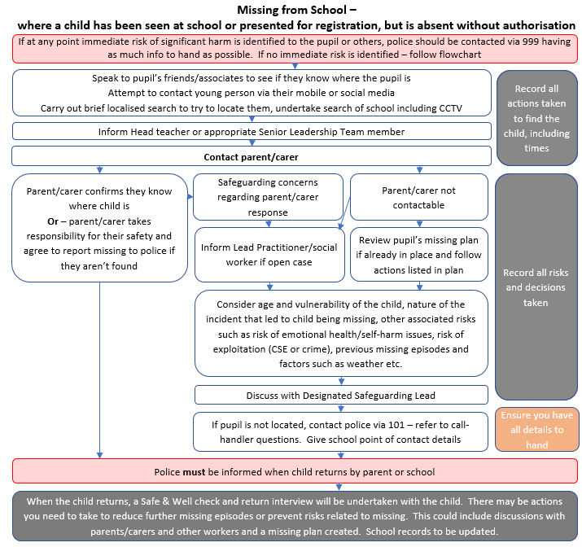

Children Looked After, Missing from Care Protocol

1. Introduction
1.1 This guidance has been produced to advise Placements and those Social Workers who are case holders for any Child Looked After who goes missing.
1.2 This guidance is written in conjunction with local, Greater Manchester and national policies and will support understanding of the process and how it is applied in Bolton.
1.3 The process is to safeguard Children Looked After who go missing and to inform care planning.
1.4 Compliance is in accordance with agreements signed at the start of the placement with residential placements.

2. When a Child/Young Person goes Missing
2.1 When a child or young person is not where they are supposed to be, prior to reporting them as missing the responsible adult is expected to take proactive steps to trace the young person prior to contacting the Police. This would include actions like:
- Physical checks of the residence or where they might be hiding
- Physical checks of the garden, garage, sheds, grounds, and surrounding areas
- Attempts must be made to contact the person directly, via mobile phone, text or social networking sites
- Contacting family and friends to ask if they are there
- Any other likely place they would be at
2.2 If the person is found via the above actions, they should not be reported as missing to the Police unless there are significant safety issues with the child being there. In such circumstances, the reporting individual should contact the police and request a ‘Concern for Welfare’ address check.
2.3 If a child is located but does not wish to return, the police may be requested to assist in their safe return, however the individual must not be reported a missing simply to ensure police involvement in the return of a child.
2.4 If the child is not found via the above actions, placement will report to the local Police that the child or young person is missing and provide the information that would assist the Police in locating them. If the child is at immediate risk of harm, ring 999, otherwise all other missing reports should be called in on 101. The police have confirmed that logging online is not appropriate for missing reports – these must be made by calling.
2.5 For all missing reports, the Placement must inform mfh@bolton.gov.uk (any time of day or night). Also, if it is during the day, they need to notify the child’s social worker (or duty team). If out of hours, EDT should be informed. The info needed for notification is listed in Figure 1.

Figure 1

Notification to Local Authority of Child / Young Person going missing

- Name of Child
- Date and Time they went missing
- Date and Time it was reported to the Police
- Summary of circumstances leading to the missing episode
- What do you think is the intent of the child/ young person going missing, where they are likely to head, if known?
- Nominated person and phone number for contact and discussion

2.6 If the child or young person goes missing out of hours, a report should be sent through to EDT. EDT will then have the up-to-date information should further discussions/arrangements be required with the Police and placement.
2.7 All info about children reported missing is recorded on our system, we need this first to identify a pattern of missing for the child and make sure that the correct support is offered, but also to be able to report our response to managers and inspectors. Info such as the date and time of the missing episode and the circumstances/reasons for the missing episode are needed. Later, return information will be added.
Figure 2.
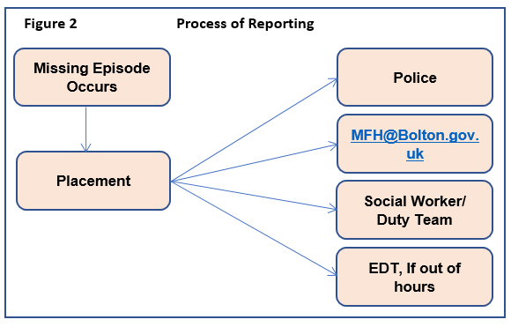
3. Once the Child / Young Person has Returned.
3.1 When a child returns or is found, placements must immediately contact everyone as before: Police, Missing from Home email, Social Worker, and EDT if out of hours. As before, date and time of return, where they were found, any circumstances need to be shared. See Figure 3.
Figure 3
Notification to Local Authority of Child / Young Person Returning to Placement having been Missing

- Name of Child
- Date and Time they went missing
- Date and Time they returned to placement
- If not directly returned to placement, where were they found
- Any commentary provided by the child/young person as to their activities
- Any alterations in care made by the placement to reduce the likelihood of further missing episodes

3.3 The process will not be completed with the return of the child or young person to the placement. There is a statutory requirement for a Return Interview to be conducted with the child or young person within 72hours of them returning.
4. Independent Return Interviews
4.1 Following an episode of missing there is a requirement for an Independent Return Interview to take place within 72hours if the child or young person agrees. The choice must always be given, even if the child has previously refused. If the child is placed outside of Bolton, the Missing from Home Coordinator can arrange for the independent service to offer a telephone return interview. The social worker may prefer to complete this with the child, in this case, they should inform the MFH coordinator and send them a completed copy to be added to the missing record.
4.2 The Missing from Home Coordinator updates the system with return information and uploads the return interview to be accessed by social care services. The return interview is not usually shared with placements as return interview is offered confidentially and may include information about other children or adults. Any relevant information and changes to the care plan should be shared by the social worker with the placement.
4.3 The Social Worker should reflect on any additional information drawn from the return interview and integrate the learning in the Care Planning process. This should include actions to enhance the child’s experience and reduce the risk of repeat missing episodes.

Return interview template



Return Interview form
Young Person Name: | Date of Birth: | Age:
Missing date(s) and time: | Return date(s) and time:

Primary reason for missing (Choose an item.) and additional reasons (Choose an item.)

Name of worker completing RI:
Agency:
Telephone: | Email:
Date of contact(s) to complete return interview, method of contact (phone/visit etc), outcome and response:
Date RI was completed: | Date RI was sent to local authority:
Reason for non-completion within 72 hours:

Detail info collected from parents/carers/other professionals that is relevant to the missing episode (identify who provided information):
Additional info from the young person, including presentation:
Recording of Return Interview with young person
What happened before you went missing?
Were there any issues that made you decide to leave?
What happened when you were missing?
Where did you go and who were you with?
What happened when you returned?
What did you do to keep yourself safe? Did you learn anything?
What good decisions did you make?
What additional support/help might stop you from being reported missing again?
Or – would you do something differently?
Concerns
Strengths
Actions taken following return interview

Partnership Information Sharing Form

Greater Manchester Police
Partnership Information Sharing Form

Sharing of information is critical to developing a clear picture of local issues and wider community related problems, which can inform Police and Partner actions to reduce threat, risk and harm.
Greater Manchester Police and the wider policing family is intelligence driven – and rely heavily on intelligence from our communities, partners and law enforcement agencies, which, often without realisation, could provide crucial links where gaps in intelligence might exist.
This form gives professionals a safe and direct way to share information with Police. If the information known to you is non-urgent, not a crime and a child / adult is not at immediate risk, this is appropriate to be shared as police intelligence using this form.
Information shared on this form could include a variety of points, such as; information about suspicious activity, an unusual exchange between two or more people, something that makes you feel uncomfortable, or information that would help Police to safeguard vulnerable people.
Anything of immediate risk should be reported via 999 or 101 to the Police Control Room. This form does not replace your usual practice of referring to Children’s Services or Adult’s services etc.
Please provide as much detail as possible regarding names, nicknames, dates of birth, descriptions, vehicle details and relevant addresses.
Please be assured the information you provide is strictly managed and your details will not be incorporated in any subsequent intelligence reports.
Have you made any other referrals or reports to any other agency regarding this or associated matters? (e.g. GM Police; Children’s Social Care, Youth Justice Service, Health, Education)
If YES, please state which agency here:

Government Security Classification (GSC):
Partner Agency Intelligence Form
Name & contact details of person completing this form and the organisation that you work for. |  | Date/Time of Report (dd/MM/yyyy HH:mm)
Person who has provided the information.  name, DOB, address & telephone number |  | Date/Time the information was shared with you.  (dd/MM/yyyy HH:mm)
Information provided:
Provide as much detail as possible on the information being provided (What, When, Why, Where, How)

This section should contain as much detail as possible about the information being provided.
It should be what the person told you without any opinion or research.
Your Research:

In this section, you may add any research such as information you hold relating to the named individuals / addresses.
Provenance :

This is extremely important as it allows the police to assess the risks to the person providing the information.

What are the circumstances of how this information came to your attention? (during a home visit / case conference)

When did the person providing the information become aware of its existence? (time/date/place)

How did the informant find out about this information? (observed, told by another or overheard)

Who was present when the informant found out? (friends/family/members of the public)

Is this information only known to the informant?

What is the risk to the informant should someone find out they have spoken to you about it?

Who was present with you, when this information was obtained? (co-worker, other partner agencies)

Has this information been recorded elsewhere? If so, where is the information held? (Daybook, MICARE, your organisations computer systems)

Have you provided this information to anyone else either by document or verbally?
Please list as appropriate.

Are you aware of any action having been taken on this information prior to it being supplied to the police?

Would the person providing the information be willing to speak to Police further?

Operation:
Are there any operations that you are aware of that are linked to this intelligence? (Op Phoenix, Op Trapped)

Recipient:
Who, within the police, needs to know this information? (Safeguarding unit, Challenger, individual officer)

If you require any assistance in relation to this report, please contact the Force Intelligence Bureau at GMP. 0161 856 6725.
Email the completed form to FIB@gmp.police.uk

National alert notification form

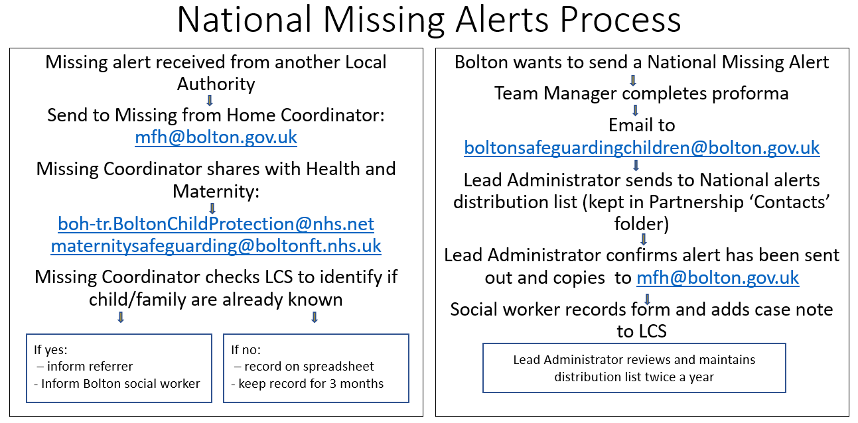
NATIONAL ALERT NOTIFICATION FORM
Date:
CHILD/YOUNG PERSON’S DETAILS (add new lines for additional children)
Family Name | Given Name | Date of birth/EDD |  | Gender
PARENT DETAILS
Family Name | Given Name | Date of Birth |  | Mother/ Father/Partner
Last known address:
Postcode: |  |  | Telephone:
Reason for Alert:
Background:
Current Concern:
If child is located, please contact Bolton Children’s Services – see below
Name: |  |  | Job Title:
Telephone: |  |  | Email address:
Outside office hours:
Person Notifying:
Job Title:

Trigger Plan

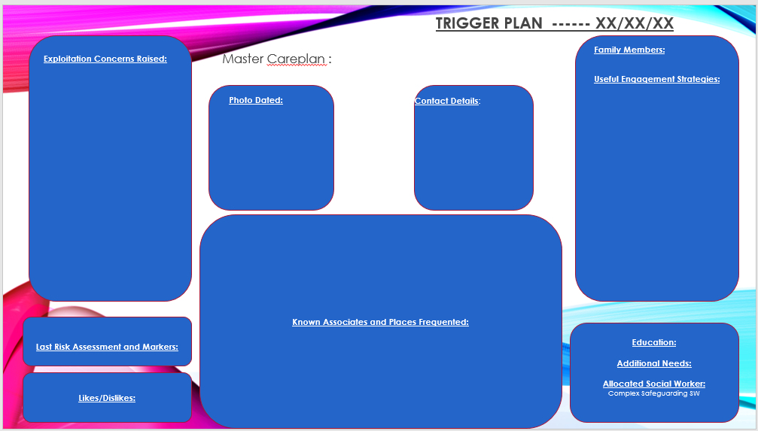

This is a change from the previous protocol, which was that strategy discussions were to be convened when a child had been missing for 72 hours. The Bolton protocol requires more than the statutory minimum, which is a local response to prioritise the welfare of children who are missing. This change is being introduced in March 2025 and will be evaluated after 6 months.

