Youth Justice Service Resettlement Policy

Author (name): | Sarah Dawson
Author (designation): | Operational Manager  Complex Safeguarding and Youth Justice Service
Approved by: | James Cooke,  Head of Service, Complex Safeguarding and Youth Justice
Date approved: | March 2025
Review Date | March 2026
Key words | Resettlement Policy

Version control

Version | Author of changes | Date | Revisions from previous issues | Circulation
1.0 | Sarah Dawson | June 2020 | New Policy | Shared with staff via Tri-X, Team Briefing and Supervision discussions
2.0 | Sarah Dawson | August 2021 | Update to include victim safety planning and additional diversity needs provision | Shared with staff via Tri-X, supervision discussions and email
3.0 | Sarah Dawson | Oct 2022 | Update to include changes to CaRT process, inclusion of Local Operating Standards relating to Resettlement and change from Youth Offending Team to Youth Justice Service. | Shared with staff via Tri-X, supervision discussions and team meeting
4.0 | Sarah Dawson | Nov 2023 | Update to include access to City Wall mentoring programme | Shared with staff via Tri-X, supervision discussions and team meeting
5.0 | Sarah Dawson | Mar 25 | Update to include YJB updated case management guidance, new local process for accommodation issues, Youth Remand Concordat Feb 2025. | Shared with staff via Tri-X, supervision discussion, emails and team meeting

CONTENTS

Introduction 4
Purpose of the Document 4
Implementation, Responsibilities and Review 4
Background 4
Pathways to Resettlement 5
Five Principles 6
Service Development 7
Governance 7
Bolton YJS Resettlement Practice Guidance 8
Appendix 1 – Local Model of Delivery 13
Appendix 2 – Bolton YJS Local Operating Standards. 15
Appendix 3 – Bolton YJS Custody, Resettlement and Transitions Panel 16
Appendix 4 – Bolton YJS Resettlement Sub-Team 19
Appendix 5 – Role of YJS Education Worker when Young Person enters custody 20
Appendix 6 –Key Standards 21

Introduction
- Resettlement of children from custody is a statutory responsibility of local authorities and is carried out in partnership with agencies including Police, Probation Service, Health and the Youth Custody Service.

Purpose of the Document
- The purpose of this Policy is to provide a guide to the resettlement of children in Bolton, with reference to the underpinning principles of constructive and effective resettlement based on recent research and guidance.
- This Policy will sit alongside the Case management guidance - Custody and resettlement - Guidance - GOV.UK. The case management guidance supports Youth Justice staff in planning for effective resettlement. In addition, there is local guidance (Appendix 1) providing Bolton Youth Justice Service (YJS) with local practice guidance to assist in providing a high standard of resettlement practice for children in Bolton.
- Please also see Youth Remand Concordat – Working together to improve the experiences and outcomes of children on remand – Feb 2025, Ministry of Justice for guidance around remand, and Bolton Bail and Remand Strategy.

Implementation, Responsibilities and Review
- The policy will be stored and be accessible to all staff on the Council intranet page and within the service settings where there is limited access to IT.
- Managers should ensure that staff are aware of this policy and where it is available.
- All staff are responsible for complying with this policy.
- Managers are responsible for monitoring compliance with this policy.
- The policy will be reviewed annually by the relevant YJS management team.

Background
- The Youth Justice Board (YJB) ‘How to make resettlement constructive’ document states “By the very definition and nature of custody, children within the secure estate (SE) are the most vulnerable and damaged. Also, the behaviour of these children often holds greatest impact for the communities in which they live”. Over the years there have been a number of research projects and initiatives to improve resettlement outcomes for children yet despite these outcomes remain poor. It is crucial therefore that the lessons to be learned from the findings are used to develop the best and most effective practices designed to support children, their families and the community if we are to achieve better outcomes for all. This has taught us that crucial elements for effective support include:
- A continued focus on resettlement throughout sentence
- Early preparation for release
- Effective communication between institution and community agencies
- A coordinated holistic response involving multi-agency partnerships
- The research is clear that resettlement must be seen as a journey for the child rather than a single transition event. There must also be support for the child to facilitate a shift in identity for the child, away from a pro-offending identity towards a pro-social identity, keeping in mind the YJB’s guiding principle of ‘Child First, Offender Second’.

Pathways to Resettlement
- In order to achieve effective and sustainable resettlement for children, the resettlement journey must begin at the earliest point therefore the process begins at point of sentence.
- The 7 Pathways for Resettlement (below) should be considered as part of all intervention planning alongside any individual needs of the young person and should be considered right from Initial Planning Meeting.

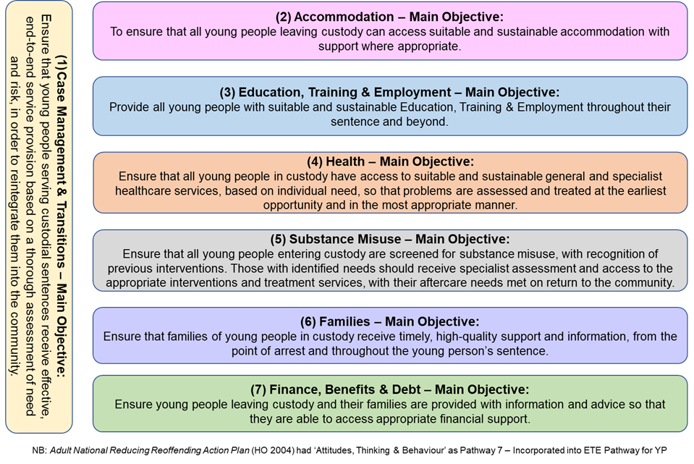

Further understanding of the above pathways can be seen here Section 7 Annex Pathways to Resettlement.

Five Principles
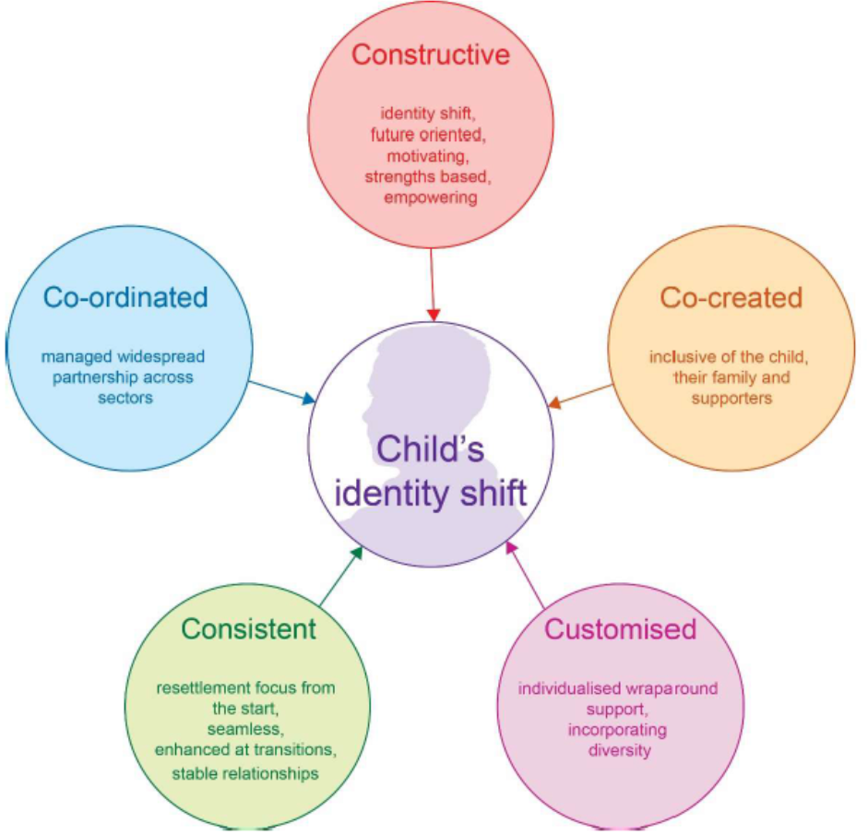
- Constructive Resettlement reflects the evidence that all work with a child needs to follow the following 5 Principles:

- In addition, the principle of ‘Child First’ promotes the development of individual strengths and capacities to develop their pro-social identity for sustainable desistance. It requires a move away from a deficit model of practice. All work should be future-focused and built upon empowering the child through supportive relationships allowing them to fulfil their potential and make positive contributions to society.
- Based on the 5 principles, Bolton YJS should deliver work that is:
Constructive – focused on the future, positive and useful, with an emphasis on strengths within the family and of the child. In addition, the resettlement of children in Bolton will be mindful of the need to work in a trauma informed way, taking into account the Adverse Childhood Experiences that a child may have experienced and the impact of these ACEs upon behaviour and needs.

Co-created – assessment and effective planning produced in collaboration with child, family and social and professional network. The voice of the child and parents should be evidenced throughout the whole journey with the child – in each stage of assessment, planning, intervention delivery and reviewing.
Customised – individual plans and interventions that are tailored to meet the needs of the individual child, designed to be delivered in the way that suits their needs and at a level that best supports them to make a positive identify shift
Consistent – planning for Resettlement will start at the first opportunity when a child enters custody and continues throughout the journey. The resettlement work should be a fluid process which provides a seamless transition through custody, into the community and throughout the life transitions that the child will experience. The structure of the team will allow for consistency of worker from assessment throughout sentence.
Co-ordinated – working in partnership across agencies and with the child and their family to dovetail with any additional agency plans and interventions for the child. The YJS will work alongside partners to ensure that resettlement work complements and is complemented by the work of other agencies. This will be particularly important when looking at the 7 Pathways in planning for resettlement.

Service Development
- In order to ensure that service delivery around resettlement is dynamic and responsive to need, a number of monitoring processes will be written into the local appendix to ensure that any disproportionality, local offending trends and recidivism factors are tacked and factored in to service delivery. Bolton YJS is part of the Greater Manchester Resettlement Consortium which provides an opportunity to share practice and develop collaborative approaches. Greater Manchester YJS’ also provide funding for a 1.0 FTE Greater Manchester Safeguarding Social Worker based in Wetherby Young Offender Institution (YOI) who provides the Resettlement Group with data around children from Greater Manchester in Wetherby YOI.

Governance
- The YJS Head of Service will provide quarterly data to the YJS Management Board representatives including outcome measures for children in custody and resettlement. This will provide an opportunity for a multi-agency response to changing need which will ensure a collaborative approach across services.

Bolton YJS Resettlement Practice Guidance
- If a child is at risk of entering custody:
- YJS complete Assetplus PSR, Bail Recommendation, or Placement Notification Stage including custody module and send to YJB. This should be done no later than the day before sentence.
- Refer to YJS Health Practitioner to complete CHAT health assessment prior to court where possible.

- Once a child is sent to custody:
- The child to be seen in court cells and assessed for safeguarding/risk concerns.
- Complete Post Court Section of Assetplus ensuring any concerns from Post Court interview are recorded clearly.
- Notify YJB Placement Team and send Assetplus – also verbally advise if there are concerns.
- Ensure parents are aware of sentence and placement details.
- Notify other relevant agencies e.g. Social Care if the child is a child looked after (CLA).
- YJS case manager to book slot in Custody, Resettlement and Transition Panel. If there are accommodation issues for release planning, these will be referred into Children’s Social Care accordingly.
- Notify YJS education worker who will begin their process.

- Youth Justice Application Framework (YJAF):
- Once a child arrives in Secure Establishment (SE) the Assetplus should be reviewed and updated by SE and Bolton YJS case holder should follow Bolton YJS YJAF guidance for the process throughout the child’s time in SE. It is important to use YJAF to access information from the SE including case notes and any assessments completed, and these should be recorded into IYSS records.
- Where there are issues with SE not using YJAF these should be addressed initially by a discussion with SE caseworker and if this is not effective then should be discussed with manager who can escalate.

- Initial Planning Meeting:
- Initial planning meeting to be held within 10 working days – this should be face to face meeting unless this is not logistically possible, due to distance for example, but any change to this would need to be by exception and only with agreement with a manager.
- YJS caseworker will invite parents/carers to the meeting and facilitate their journey by taking them with them. If this is not possible this to be agreed by manager.
- Relevant external agencies/internal Bolton YJS specialists will be invited to meeting.
- Resettlement planning begins at this meeting as per Bolton YJS Resettlement Policy. Sentence planning should include expectations on the child whilst in custody, management of risk and safeguarding across custody and community, and should have a focus on the Resettlement Pathways from the start.
- Sentence Planning dates (future meetings) should be agreed at this meeting and recorded in IYSS as forward meetings.
- Record of details of meeting in IYSS and Assetplus review should take place. Assetplus review to be completed as per YJAF guidance. Bolton YJS case manager is responsible for ensuring that Pathways and Planning document meets our resettlement policy requirements.
- The Pathways and Planning section of Assetplus is the resettlement plan. This will focus on the 7 pathways with a specific additional objective around offence focused work. Each will have an objective of the relevant pathway with an additional objective that covers compliance expectations and Interventions. Workers can use the template provided to ensure that the model is followed, and this will in turn ensure that all aspects of resettlement planning are in line with the policy. This plan will then be discussed at Custody, Resettlement and Transitions (CART) Panel to ensure we have met the needs of the young person.

- Review Meetings:
- Review meetings to take place at a minimum of three-monthly intervals. These to be face to face as above.
- Where sentence is less than 6 months; Review meeting to take place in line with SE guidance.
- Assetplus Review to be completed as per YJAF guidance. Bolton YJS case manager is responsible for ensuring that Pathways and Planning document is in line with our resettlement policy.

- Pre- Release Meetings:
- Release Preparation Meeting – penultimate meeting which must be no later than one month prior to date of release. This should trigger the opening of the Assetplus Release from Custody stage which should be completed prior to final release meeting. This meeting will finalise arrangements for the community element of resettlement (notice of supervision/licence) ensuring that resettlement plans are focused on the Resettlement Pathways, promote desistance, and support the child in a positive identity shift using a model of Child First.
- Licence conditions must be proportionate and designed to promote a child first approach, be strengths based and reduce concerns for the safety of the child, alongside requirements necessary to reduce likelihood of re-offending and reduce concerns for safety of others. In considering these conditions notice must be taken of the notice of supervision list of available requirements and the YJB case management guidance around managing post custody periods.
- NB. The Youth Justice Board strongly recommends that ISS is not used as a licence condition. It notes that Intensive Supervision and Surveillance is an important alternative to custody. However, the evidence shows that it is not effective in supporting children post custody, and may encourage, rather than reduce, future offending behaviour. Intensive Supervision and Surveillance is therefore unlikely to ever be appropriate or proportionate as a licence condition.
- Final release meeting – this should take place no less than 10 working days before release date. This meeting will agree transport arrangements for release, YJS contact on release and remind of final licence conditions.
- Assetplus review to be completed as per YJAF guidance. Bolton YJS case manager is responsible for ensuring that Pathways and Planning document is in line with our resettlement policy.

- Additional Support:
- YJS case manager will visit the child no less than monthly unless this is not logistically possible. Where this is the case (and has been agreed with manager) other methods of contact should be used to maintain regular contact with the child. These visits will focus on the resettlement pathways and resettlement planning.
- YJS Resettlement Support Worker will visit the child additionally and separately from the visit by case manager. This is to increase level of contact by YJS during time in SE. These sessions will be relational but with an element of structure focusing on the resettlement planning and delivering interventions to support the plan. These visits will be no less than monthly unless this is not logistically possible at which point other methods of communication will take place. A key function of these visits is to develop a positive relationship between resettlement support worker and young person and in doing so identify the strengths, skills, support network, aspirations and goals that can be built upon to support a pro social identity shift. The worker will also work with parents to support the identity shift.
- YJS case manager will visit parents/carers at least monthly for duration of time in SE. The focus of these visits will be to engage parents/carers in the resettlement pathways planning for constructive resettlement. This may include an offer of parenting programme which would be delivered by Support Worker in YJS.
- Resettlement support worker will support YJS case manager and YJS education worker, alongside any additional specialist workers, to ensure that all identified aspects of resettlement planning are in place. This may include setting up appropriate positive activities/mentors ready for release.
- All children who are sentenced to custody will be assessed by Bolton YJS SALT unless it is agreed that there is a recent/relevant assessment (within last year) hence a new assessment is unnecessary. If decision is made not to complete a new assessment this should recorded along with rationale in Pathways and Planning document. Follow up support in custody can be done by YJS SALT as required.
- YJS health practitioner will liaise with SE and YJS case manager to agree what health support will be given during time in SE. This may include visits to the child, liaison with SE Health staff, liaison with community health provision and will include completion of CHAT/input into CHAT done by SE. All identified needs will be planned for as part of resettlement plan in order that there is smooth transition into services in the community.
- YJS emotional/mental health practitioner will visit the child for initial well-being check and will continue to offer monthly well-being checks which may be by visits, telephone calls. Any concerns will be addressed by direct support or intervention, liaison with SE or community provision. All identified needs will be planned for as part of resettlement plan in order that there is smooth transition into services in the community.
- YJS victim worker will work with children in SE to provide opportunities for restorative justice if appropriate. Consideration of any victim safety issues will take place during sentence to ensure a robust response to manage any risks is in place for release and any Release on Temporary Licence (ROTL) opportunities and plans. These will be discussed and agreed with case manager and operational manager.
- Consideration of referral to City Wall for transition mentor to take place. City Wall mentor can visit children in SE and build relationship ready to support resettlement in custody and on release.
- Additional diversity needs must be considered in all aspects of resettlement work throughout custodial and community stages of any remand/sentence. This must include consideration of cultural, religious needs, disability, gender and sexual orientation. Referrals to support services, for example BAME support projects, should be considered and built into resettlement work both in and out of custody, and work should be in line with the relevant policies for example, GM Working with Girls Policy for females.

- On release:
- If YJS are transporting the child from SE it is likely that they will take the child home at the end of the journey. If, however the child is subject to Intensive Supervision and Surveillance (ISS) licence they must attend the YJS in order to be given the timetable and meet the ISS worker.
- If the child is not being collected from SE by YJS the child must be seen at the YJS that day – appointment will be given at Pre-Release Meeting.
- Contact for all children released from custody will be a minimum of twice per week regardless of length or risk levels. This is to provide support around the resettlement plan.
- Case Manager will carry out home visit within 5 working days of release, speak to parents/carer twice per week and have ongoing face to face contact at least once every two weeks.
- If a child has turned 18 years old whilst in custody before the mid-point of their sentence, they will be subject to an extended period of supervision which will be in place for 12 months from the mid-point of sentence. This extended period is a rehabilitative support measure not punitive and any decision to breach should be balanced with overall progress and be in the best interest of the child and public.
- Planning meeting for resettlement should take place within 5 working days of release. This must include the child, parent or carer, YJS workers and any other relevant professional where possible.
- A review of progress should take place within 1 month of release and no less than three months thereafter. Resettlement practitioner from SE should be invited to attend. The reviews should focus on progress against Resettlement Pathways and Planning which should be reviewed fully in order to be responsive to progress made, changes in circumstances and the needs of the child/parents and carers, desistance factors/ risk and safeguarding concerns.

- Enforcement:
- Process will be the same as in community orders. The child may receive a first then a final warning, followed by a breach review chaired by a manager to try to re-gain compliance. As in community orders, if the case worker considers that the breach is so serious that this should result in breach action outside of the warning process this will be discussed with a manager.
- Greater Manchester Court breach paperwork will be completed.
- Breach proceedings can be brought to court even after the order has ended as long as the summons or warrant was issued whilst the order was in force.
- The court can issue a period of detention or a period of supervision of three months starting from the date of the failure to comply. This can run concurrently to the licence and further periods can be imposed for further breaches.

- Recording / IYSS:
- Ensure all meetings are recorded in IYSS.
- Record meetings as planning meeting or review meeting not as a prison visit. Prison visits should be recorded as such.
- Record evidence of all contact with children, parents/carers and other relevant contacts in IYSS.
- Ensure all information from SE is recorded in IYSS, and also upload assessments, reports, minutes from meetings or other documents into IYSS Multimedia saved with title and date. If you record ‘minutes to follow’ these need to be then added. If there are minutes to follow please record the key points and actions from the meeting so that these can be carried out.
- Copies of sentence plans and reviews should be sourced and stored in IYSS Multimedia. If there are issues accessing these plans, this should be discussed with a manager.
- When recording meetings or contacts please ensure you record who was present including, YP and parent/carer.
- When recording contacts/meetings please include strengths and positives however small.
- A review of Assetplus and Pathways and Planning must take place at each transition. This includes entering or leaving custody, move to another SE, change from remand to sentence or bail, case closure.
- Remand cases – Pathways and Planning in Assetplus needs to also plan for possible bail application and outline any community planning to manage risk and safeguarding as a contingency until P&P reviewed within Assetplus review on transition.
- Bail cases – Pathways and Planning in Assetplus needs to include plan for community and also custody, including planning for management of risk and safeguarding for each contingency. If this is Bail Recommendation Assetplus and outcome is remand, a strong plan at this stage will allow worker to use that plan for first month of custody. Assetplus review should then be done at 1-month stage to incorporate initial planning meeting information.
- Ensure Pathways and Planning reflects the resettlement pathways and is strengths based, supports identity shift, recognises diversity needs and manages risks to young person and community. Try to build some enjoyable experiences in P&P for the child where possible based on their views.
- Evidence the use of the planning tool in the recording of planning process. This should be used with every child/parent as part of the planning process. This should be uploaded into Multimedia and saved with name, title, and date.
- Ensure actions from Multi-Agency Risk Meetings (Marms) are evidenced in P&P and case recording.
- Transition planning should be done prior to any transition/move – for example pre-release for transition from custody to community to ensure plans are in place before release.
- Transition planning should show how the resettlement pathways will continue through the journey from custody to community or vice versa.

Appendix 1 – Local Model of Delivery

- This appendix details the model of local processes for the resettlement of children and children in Bolton. It is designed to be read in conjunction with the Bolton YJS Resettlement Policy, the Youth Justice Board Case Management Guidance on Custody and Resettlement and Bolton YJS Local Operating Standards (Appendix 2).
YJS Management Board Senior Manager Oversight
YJ Operational Manager Oversight
Custody Resettlement and Transition Panels
Multi-agency Risk Management Meetings
Greater Manchester Resettlement Group
Bolton YJS Resettlement Support Team
Young Person in Secure Estate
Bolton YJS Local Delivery Model

- YJS Management Board – YJS Head of Service will present data to the board on a quarterly basis – to include short brief on each young person in custody – offences, journey to custody, bail applications, any risk or safeguarding issues in custody, update on resettlement planning, feed in info from the Custody, Resettlement and Transitions Panel. Board will provide a multi-agency opportunity to remove blockages to effective and constructive resettlement. In addition, the YJS Head of Service will discuss children who are looked after within the Senior Leadership Team Meetings.

- Custody, Resettlement and Transitions Panel – monthly multi-agency panel which will discuss all children placed in the secure estate and all cases preparing for transition into adult provision (Appendix 3). Extraordinary meetings will be convened when children are remanded into custody to ensure response is swift. Cases will return to Custody, Resettlement and Transition Panel for review a month after release, in order to discuss progress and identify any barriers to effective resettlement which will be escalated to YJS Head of Service / Management Board if necessary. Accommodation is a key part of resettlement planning and there is an agreed Key Standards agreement across GM DCS’. See Appendix 6. Should there be concerns around accommodation planning for children, an escalation process to be followed is to escalate from Operational Manager to Head of Service who will then escalate to Assistant Director/Director as appropriate.

- Multi-Agency Risk Meetings (MARMs) – MARMs will be held on children in custody. These will take place in the secure estate and will include the child and parent/carer plus additional relevant agencies as appropriate. Where possible these will be amalgamated with the sentence planning and review meetings held by the secure establishment and will be attended by YJS Operational Managers who will widen discussion to include risk management.

- Greater Manchester Resettlement Consortium – YJS Operational Manager and YJS Education Worker will continue to attend the Resettlement Group and ensure initiatives and learning from that group is incorporated into Bolton YJS practice.

- YJS Resettlement Support Team (Appendix 4) – whilst this is not a dedicated team or change to roles, there will be several individuals who take a key role in the resettlement of children in addition to the role played by the YJS case holder.

- Operational Manager – to oversee processes and provide feedback to YJS Management Team/HOS. This Operational Manager will also chair Custody, Resettlement and Transition Panels.
- Individual YJS Officer (case holder) – this will be regular case holder of the case to ensure consistency.
- Resettlement Support Worker – to build a relationship with children in custody by undertaking additional visits, delivering interventions in custodial environment, identify and develop links to resources in the community for constructive resettlement, support case holder to plan for effective resettlement, support parents.
- YJS Education Worker – this is a key role and the Education worker will follow current process when children enter secure estate (Appendix 2)
- YJS link Nurse – to complete CHAT (Health Assessment) when children are at risk of entering into secure estate. To share that assessment with the secure estate and to monitor the health needs of those in the secure estate. To ensure the smooth transition of health needs as we prepare for transition back into the community.
- YJS Emotional/Mental Health Practitioner – to provide consultation and support to YJS staff in managing the emotional/mental health needs of children in the secure estate. To provide a link between Camhs in the community and secure estate as appropriate. To support the resettlement planning to ensure the emotional/mental health needs of children are met. To support all staff to work in a trauma informed way to ensure consideration is given to ACEs throughout the resettlement journey.
- Other relevant workers for example Serious Youth Violence Worker/City Walls Mentor will also play a role within the process.

Appendix 2 – Bolton YJS Local Operating Standards.

Activity | Time scale | Responsible
Initial meeting | 10 working days | Case manager
Asset Plus completed | 20 working days | Case manager
Plan completed | 20 working days | Case manager
Contact | Monthly | Case manager
Contact | At least monthly separately to Case manager | Resettlement Support Worker
Contact | As required but at least once every two months | Specialist Workers
- DTO licences
Activity | Time scale | Responsible
First contact on release | Day of release | Case manager/Iss worker
AssetPlus completed | Day of release | Case manager
AssetPlus and report sent for Q/A manager | 15 working days | Case manager
QA changes to be completed | 2 working days | Case Manager
AssetPlus and report signed by manager | 20 working days | Operational manager
Intervention Plan completed with and signed by child and parent/carer. | 15 working days | Case manager
Frequency of contact | Min twice a week but more likely to be more frequent | Case manager/Resettlement Support worker/Specialist workers
Home visits | Within 5 working days of release then at least weekly thereafter | Case manager/Resettlement Support worker/Specialist workers
AssetPlus reviews | 6 monthly unless  order less than 3 months.  3 monthly if child assessed as Very High Rosh or S&W and/or High in all three risk areas. Any significant change in circumstances or transition (see guidance list) would trigger Assetplus Review | Case manager
Plan review | 3 monthly or when the child makes a transition. | Case manager and Operational manager
End AssetPlus | 15 working days of end of licence | Case manager

Appendix 3 – Bolton YJS Custody, Resettlement and Transitions Panel

Monthly Custody, Resettlement and Transitions Panel

Panel to include: Operational Manager (Chair); YJS Police Officer; YJS Education Worker; YJS Health Worker; YJS Officer (independent of case who will be YJS Duty Worker), YJS Resettlement Support Worker, Victim Worker, YJS Emotional Health Worker, YJS SALT
Attendees at Panel: YJS Case holder; Intensive Supervision and Surveillance Worker (if applicable); Local Authority Social Worker (if applicable); Probation Officer (if transitions case); other relevant workers as applicable.
Panel will sit on monthly basis in regular slot.
A member of the admin team will be responsible for management of the panel process and will manage the agenda, type up the notes into key summary of discussion and action points and record in IYSS (YJS Case Management System).
Chairing of panel will be done by Operational Managers. Case Managers will be responsible for referral of children into panel process.

Purpose of Monthly Panel

To discuss any case where:
- The child receives a custodial sentence (custody review and resettlement planning)
- The child begins a transition process from youth to adult provision
NB: where a child is remanded into custody the case will be discussed at an extraordinary panel (see below).

Custodial Sentences

The purpose of the panel in relation to children who have received a custodial sentence is twofold:

- To review the Pre-Sentence Report (PSR) proposal along with PSR, and to consider whether the YJS has managed the case effectively; to identify any areas where we could have worked differently, which may have impacted upon the outcomes for the child and to use these to drive development of future practice; to identify any gaps in provision that may have provided opportunities to change the outcome and to examine how these gaps may be addressed in future.

- To discuss the resettlement process in preparation for release from custody. The Resettlement Plan which focuses on the 7 pathways will be drawn up as part of the Assetplus and including information from the initial planning meeting and any MARM and then will be brought to the initial CaRT Panel and any gaps identified and actions agreed. Any additional input from specialist workers can also be agreed alongside any victim safety issues and RJ options. If accommodation is a concern or the child is a child looked after, this will be discussed and referral made to Children’s Social Care as appropriate. The worker can then take away any agreed actions and make amendments to Pathways and Planning plan. The resettlement plan will support the pathways throughout sentence and for shorter sentences focus on resettlement in the community from initial CaRT Panel, whilst for longer sentences the resettlement plan will support the pathways through the sentence and from 6 months prior to release focus will move to specific actions to prepare for release. This will ensure that resettlement is effective (refer to YJB Constructive Resettlement Guidance).

- Custody: To review case of any child who receives a custodial sentence to identify good practice in that case or identify any learning points to improve service delivery. To provide relevant information to YJS Head of Service and YJS Management Board to identify any resources needed to improve resettlement work in the YJS, or to escalate concerns re any individual or pattern of needs. NB. Remand reviews should take place out of this model as timescales should be within five working days of the initial remand to identify any action that should be taken to consider and/or support a bail package. Remand reviews would be chaired by case manager’s line manager.

- Resettlement: To identify any issues, barriers or gaps in provision relating to each resettlement pathway and to agree actions across the multi-agency resettlement practitioners to ensure resettlement is effective and constructive.

- Transitions: To monitor the transition planning for individual children regarding the transition to adult Probation Service. To identify any issues or barriers to effective transition and to escalate those to YJS Head of Service and/or YJS Management Board. To feed into the monthly YJS and Probation Service transition meetings.

Model

Case discussions around the resettlement work for each individual child will take place within regular supervision sessions with line managers and practitioners.
Risk management oversight will take place within case supervision and multi-agency risk meeting processes (MARMS).

CaRT meeting – monthly meeting consisting of a standard panel of resettlement practitioners including YJS Police Officer, YJS Probation Officer, YJS ETE Worker, YJS link Nurse, YJS EMH Practitioner, YJS Victim Liaison Worker, YJS SALT and chaired by YJS Operational Manager. In addition, other specialist workers including 360 Substance Misuse, City Wall Transition team may also attend if relevant. This panel will provide resettlement support and actions to support effective and constructive resettlement across resettlement pathways. YJS Case Managers and Resettlement Support Workers will attend for their individual cases. YJS admin lead for resettlement will provide a record of the discussion and actions agreed on the CaRT proforma.

Transitions from youth to adult provision

The majority of these cases will be those children who are approaching 17 years and 6 months and are ready to begin the transition process from YJS to Probation Service. There may also be children who as a result of age (18) and length of custodial sentence will be transitioning from the youth to adult secure estate. The panel will be used for both these groups.
Children on community based sentences – see Bolton YJS/Probation Service Transitions Policy for local arrangements on which children are eligible for transition who are approaching 17 years and 6 months should be booked into panel for discussion after discussion between Case Manager and Operation Manager in supervision process. The outcome of this will be recorded and shared with Probation Service / Community Rehabilitation Centre at the quarterly transition planning meeting by YJS Head of Service and YJS seconded Probation Officer and a consensus will be agreed.
Discussion will take place at panel to form the basis of the draft transition plan (The YJS Officer will then work to transition planning guidance to include any actions or decisions from panel.

Remands into Custody – extraordinary panel to be convened within five working days of initial remand

See - Youth Remand Concordat – Working together to improve the experiences and outcomes of children on remand – Feb 2025, Ministry of Justice. Youth Remand Concordat - GOV.UK . See also Bolton Bail and Remand Strategy.

All cases appearing in court at risk of remand into custody should be assessed at initial stage at court for suitability and availability of possible bail packages to avoid remand into custody unless risk is too great. It may not be possible to source the resources available to support a bail package at the time of the initial court hearing and in these instances the case should be booked into the next panel and the process below followed.
The purpose of the panel in relation to children who are remanded into custody is to review the case to examine possible interventions or placements that may provide an opportunity to support a bail application and to support release into the community which may not have been possible at time of remand. Panel should be instigated and chaired by the operational manager for the case manager and should be held within 5 working days of the remand to ensure that action to support bail is taken as soon as possible. Workers should not wait until the panel to liaise with family and other agencies to determine possible addresses that may be available for a bail package and should attend panel with this information. If it may be necessary to request funding for a placement in the community, this discussion should take place with line manager immediately after remand in order that that this can be discussed with Assistant Director of People and steps taken to identify possibilities prior to panel.
If a suitable bail package can be identified, case manager should contact defence to allow them to consider a bail application.
NB – Consideration of referral to the GM Remand Accommodation should be given GM Remand Accommodation
If resources or addresses become available through the remand period which were not initially available but may provide a new opportunity for the child to be released on a bail package the case should be booked into a second extraordinary panel.

Appendix 4 – Bolton YJS Resettlement Sub-Team

Appendix 5 – Role of YJS Education worker when child enters custody

Resettlement ETE Process

During sentence/remand ETE Worker liaises on regular basis with Education Worker in Secure Estate, ETE providers as part of Resettlement Planning Process, and Parents, as appropriate

Child enters Secure Estate
Within 10 working days
Initial Planning Meeting – YJS ETE worker has statutory duty to attend Initial Planning Meeting. ETE worker will explain role and support on offer to child

During sentence/remand
YJS ETE worker may attend additional meetings in Secure Estate, e.g. to take potential ETE providers to meet child and plan for release.

6 Weeks prior to eligibility for Release on Temporary Licence (ROTL)
YJS ETE Worker will play part in arranging/supervising of ROTL. YJS ETE worker’s role will be to facilitate ROTL, focusing on ETE resettlement planning. Pre-planning early will allow for engagement in ROTL from first day of eligibility.

10 days prior to release
YJS ETE worker has statutory duty to attend Pre-Release Meeting. Focus on ETE plan for release.

Day of Release
YJS ETE worker will meet young person as part of release appointment at YJS where possible

Licence period
YJS ETE worker will have regular contact with young person through licence period as appropriate. This will include facilitating ETE visits, Careers support, support to complete application forms for example.

Day 1-2
YJS ETE worker contacts relevant school/community education provider to share information. Information requested including historic/current education information including copy of EHCP if completed.

Week 1
Information received forwarded to relevant Education worker in Secure Estate

Appendix 6 –Key Standards

- Children in custody should know at least 6 weeks in advance of their release day where they will be living.
- Escalation should take place as soon as a difficulty in obtaining suitable accommodation is identified, by the Case Manager to their Manager and Head of Service, at a minimum of 8 weeks in advance of their release date.
- Heads of Service should raise issues with the Director of Children's Services as soon as a difficulty is identified, at a minimum of 8 weeks in advance of their release.
- Where eligible, Release on Temporary License should be considered to support successful placement.
- No child should leave custody into short term or temporary accommodation, or to present as homeless to local agencies.
- Multi agency plans should align to ensure that support is available to support the child to maintain their placement and hold regular multi- agency meeting to ensure targets are met.

