
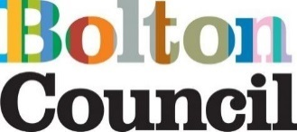

Quality Assurance Framework

March 2025

Contents:
Section 1- Quality Assurance (QA) background
Introduction
Section 2- Quality Assurance values and principles
Section 3 – What does Quality Assurance mean?
What does good look like in Bolton?
Section 4- How do we use this framework?
Section 5- Quality Assurance activity
What are we measuring?
How do we measure?
How do we gather the information as part of our quality assurance activity?
Roles and responsibilities
Section 6- Quality Assurance Schedule
Section 7- Case file audit
Steps in the case file audit process
Handling inadequate audits
Section 8- Measuring & sharing learning
Appendices

Section 1- Quality Assurance (QA) background
Introduction
Bolton Council is committed to continuous improvement, ensuring services deliver the best outcomes for children, young people, and families. This QA Framework aligns with Bolton’s overarching Children and Young People’s Strategy, clearly setting out our mission, vision, ambition, and the pathway for achieving continuous improvement. The Quality Assurance Framework monitors, evaluates, and strengthens social work practice through reflective learning, data analysis, and direct engagement with children and families.
Quality assurance goes beyond compliance by driving real improvements in practice. This framework:
- Provides a clear structure for monitoring and improving practice.
- Ensures accountability across all levels of the organisation.
- Uses QA findings to inform workforce development and service improvements.
- Embeds a whole-system approach, working collaboratively with partners.
- Ensures that Bolton’s practice standards are consistently met.
This framework is reviewed annually to ensure it aligns with best practice and statutory requirements.
This Quality Assurance Framework also aligns with Ofsted’s Inspection of Local Authority Children’s Services (ILACS) framework. It ensures that the key areas of focus within ILACS - such as the quality and impact of social work practice, leadership oversight, and the effectiveness of services for children in need of help and protection - are systematically monitored and addressed. Our QA activity supports the ongoing readiness for inspection and demonstrates a culture of continuous learning, reflection, and improvement, in line with Ofsted’s expectations of a 'self-aware' and 'self-improving' local authority.

Section 2- Quality Assurance values and principles

The QA Framework aligns with the Bolton Family Framework and is underpinned by the following core principles:
- A Restorative Approach*: Case audits are collaborative, fostering relationships with staff and managers, providing both high support and high challenge.
- Child-Centred Practice: Quality assurance prioritises children’s experiences, progress, and outcomes, ensuring their voices and those of their families/carers are heard.
- Outcome-Focused Approach: We measure impact, not just compliance.
- Positive Learning Culture: Quality assurance encourages staff development and service improvements through constructive feedback.
- Reflective Practice: Supports continuous learning and professional reflection.
- Closing the Loop: Where concerns are identified in children’s records, prompt action is taken to secure positive outcomes.
- Whole-System Approach: Quality assurance is integrated with multi-agency working through the Bolton Safeguarding Children Partnership.
- Strengths-based Practice: Builds on existing strengths to support change.
- Relational Practice: Values human connection as key to effective support.

*This approach focuses on building trusting relationships, repairing harm, and creating a culture of shared responsibility. In the QA context, it means working alongside practitioners to support learning and improvement rather than blame.

Section 3- What does Quality Assurance mean?
Quality assurance is the systematic monitoring and evaluation of practice to improve services for children. It ensures that leaders and managers have oversight of frontline work and that interventions lead to meaningful improvements.
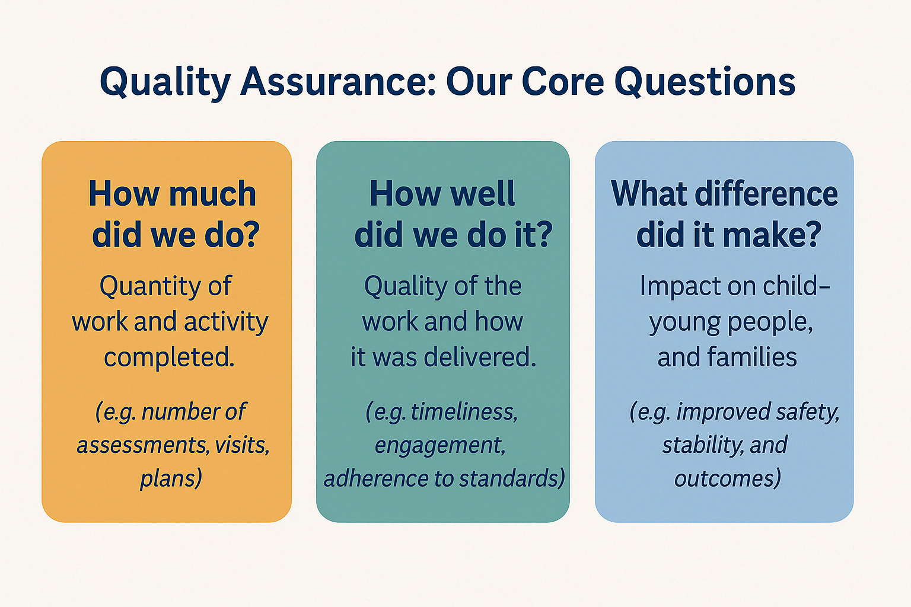
In Bolton, our quality assurance asks three fundamental questions: 1) How much did we do? 2) How well did we do it? and 3) What difference has it made to children and families?

Figure 1.

By ensuring that our quality assurance framework measures these three things, we are able to answer the ‘So what?’ question. Is our intervention helping children and are they making progress? If the answer is ‘no’, then what do we plan to do about it? Use of the framework supports practitioners, managers, and leaders to answer these questions and feed into team meetings; service meetings; improvement plans and corporate planning with clear links to established governance.
What does ‘good’ look like in Bolton?
Ofsted criteria for what good looks like can be viewed here. Inspecting local authority children’s services - GOV.UK (www.gov.uk)
Bolton’s Practice Standards explain what good practice looks like in Bolton and should be read in conjunction with this framework.

Section 4- How do we use this framework?
Quality assurance in Bolton goes beyond traditional audits. It involves the continuous collection and analysis of data and intelligence that help us understand the quality of our practice, the effectiveness of our systems and, most importantly, the impact of our work with children and families.
Quality assurance includes data from specialist areas such as Fostering and Placement Services, Early Help and the Integrated Front Door ensuring a comprehensive and holistic picture of practice quality.
Audits remain a critical tool for measuring performance and providing assurance to senior leaders regarding the strength and consistency of management oversight. Crucially, learning from audits and other QA activity is shared across the organisation to drive improvements in all areas of practice (see section 8).
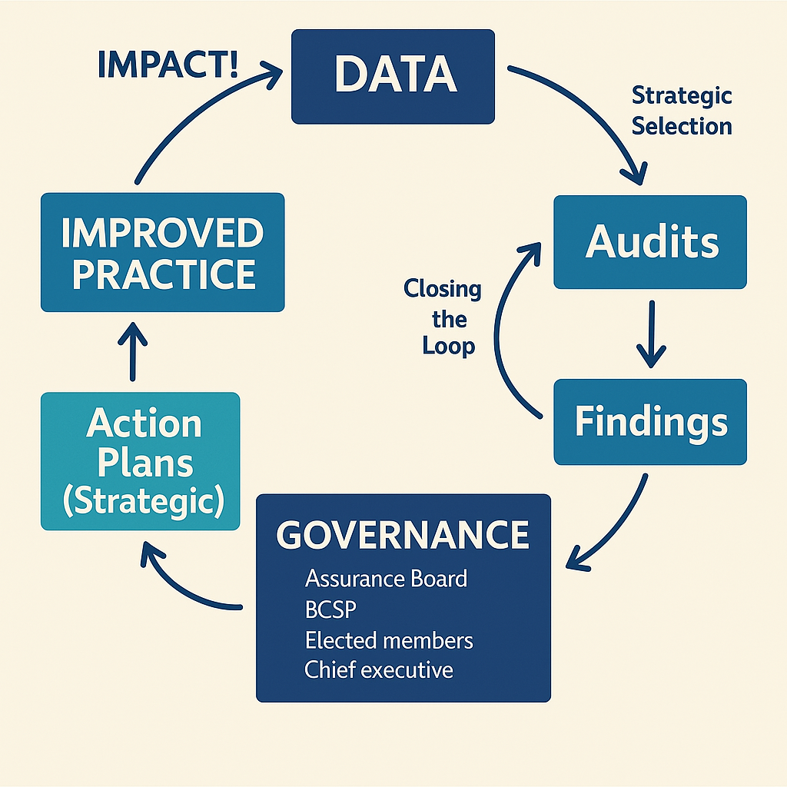
QA findings (in the form of 6 weekly, quarterly and annual QA Reports) are carefully considered by strategic leaders and inform service improvement plans, workforce development plans and multi-agency safeguarding arrangements. QA findings and the plans devised to address them are shared with the Chief Executive, Bolton Children’s Safeguarding Partnership and elected members as part of our robust governance arrangements.
Figure 2.

Section 5- Quality Assurance activity
What are we measuring?
Our quality assurance activity measures the following aspects of our work with families against our Practice Standards:
- Direct work and the child’s voice
- Quality of assessment
- Quality of planning and review
- Quality of case recording (e.g. chronology, genogram)
- Management grip and supervision
- Parent/carer engagement and feedback
- Outcome/impact/effectiveness

How do we measure?
For consistency in measuring the quality and impact of case file audits the OFSTED judgements from the Inspection of Local Authority Children’s Services (2nd September 2022; Inspecting local authority children’s services - GOV.UK (www.gov.uk) are adapted for our use:
- Outstanding
- Meets good
- Does not yet meet good
- Inadequate

How do we gather the information as part of our quality assurance activity?
We use multiple methods to gather QA insights, including:
- 6 weekly Case File Audits*
- Multi-Agency Audits (with safeguarding partners)
- 6 weekly Thematic Audits
- Performance Data Analysis (key trends, compliance, service user experience)
- Direct Observations of Practice (At least 10% of audits will include direct observations of practice, ensuring comprehensive qualitative insights into frontline social work)
- Staff & Service User Feedback (audit, complaints, compliments, surveys)
- Ofsted & Peer Reviews
- Learning from reviews i.e. Safeguarding Partnership commissioned reviews and internal learning reviews
* Audit tools are consistent across all service areas.
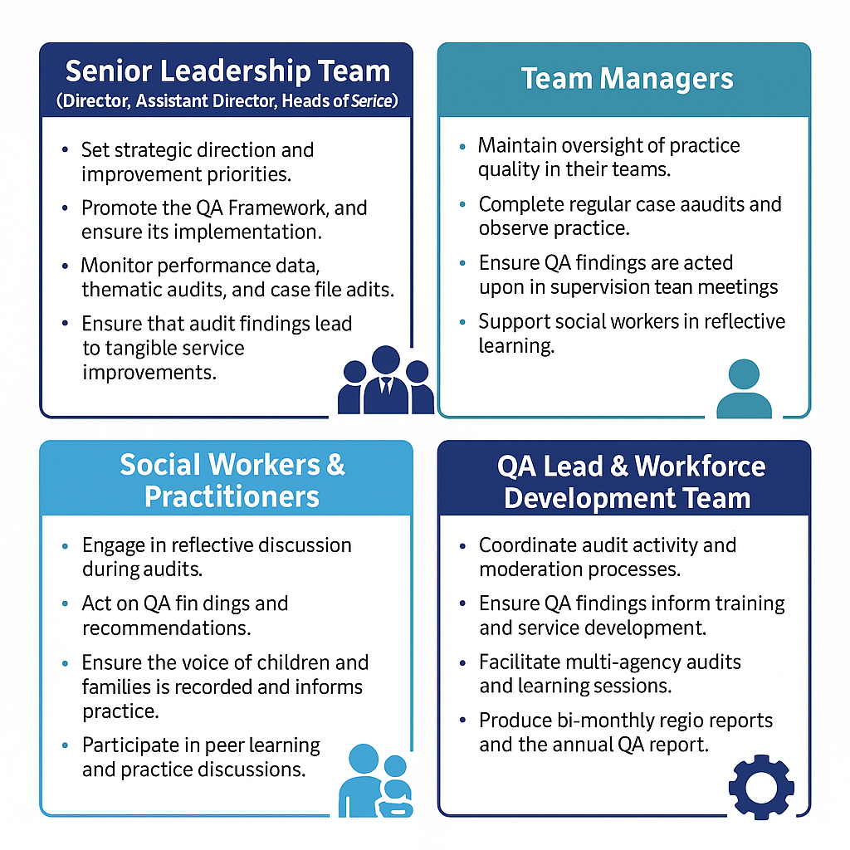
Roles and responsibilities
Figure 3.

All practitioners, managers, and leaders are responsible for ensuring compliance with Bolton’s Quality Assurance Framework, reflecting upon practice, and systematically implementing required actions and learning outcomes.

Section 6- Quality Assurance Schedule
Figure 4.
QA Activity | Who? | Frequency | Outcome | Reporting Mechanism
Case File Audits | Team Managers | 6-weekly | Identifies practice strengths & areas for improvement | Shared at AIM*, Supervision
Moderation of Case Audits | QA Lead, HoS | 6-weekly | Ensures consistency in audit judgments | Shared at AIM
Multi-Agency Audits | Safeguarding Partners | Quarterly | Strengthens partnership working | Shared via BSCP** and QA Reports
Thematic Audits | QA Lead, HoS | 6-weekly | Provides deep-dive analysis into priority areas | Shared at AIM, Practice Learning Sessions
Staff & Service User Feedback | QA Lead & Team Managers | Ongoing | Captures experiences of frontline staff & families | Shared at AIM, Themes included in QA reports
Practice Observations | HoS | Bi-annual | Evaluates the quality of direct work with children | Shared at AIM and in annual QA report

*Assurance and Improvement Meeting
**Bolton Safeguarding Children Partnership

Section 7- Case file audit
The Quality Audit Tool is found on the Liquid Logic integrated children’s system in Forms.
This tool has been designed to audit case file work that is held on the child’s file and includes an area for feedback from the child/young person/family/carer as well as feedback from the allocated social worker.
Steps in case file audit process:
- Case Selection: Cases are chosen strategically*, ensuring representation from all service areas.
- Collaborative Audit: Social workers engage in reflective discussion with the auditor.
- Feedback & Grading: Direct input from children, families, carers, and professionals is obtained. Auditors provide clear, constructive feedback based on evidence.
- Moderation: Audits are moderated to ensure consistency.
- Action Planning: SMART actions are set, with updates tracked by the QA Lead. Audit findings inform service improvement plans via overview reports to governance meetings.
- Closing the Loop: Managers and workers review audit actions in supervision to ensure issues are addressed and the Focus on the Fundamentals Framework is implemented.
- Identify cross cutting themes from audit rounds.

Handling Inadequate Audits: Any urgent concerns must be immediately reported to managers and Heads of Service.
All audit activity is recorded on the child’s file and shared with the social worker and manager. The audit actions tracker (master copy held by QA lead) is regularly updated and shared with leaders through our Assurance and Improvement Meeting (AIM). Any gaps or deficits are addressed (closing the loop). Where multiple practitioners are involved, for example the independent reviewing officer or complex safeguarding practitioner, then they too must engage in this activity.
*Cases for audit will be purposefully selected, informed by performance reports and ChAT tool insights, to address identified priorities, issues, and areas requiring focused attention

Section 8- Measuring & sharing learning
Introduction
Bolton children’s services are committed to continuous improvement in service delivery. A focus on the fundamentals will ensure we do the basics brilliantly to perfect practice and provide a foundation for consistent and impactful intervention so we can make a difference to the lives and lived experiences of our children, young people, and their families.
To focus on the fundamentals a cycle of learning opportunities will be introduced in May 2025 linked to findings from thematic audits, case file audits and informed by best practice guidance.
Learning opportunities
- Weekly virtual breakfast briefings sessions
- Weekly virtual lunch time learning sessions
- Quarterly Practice Weeks
- Quarterly Staff Engagement Sessions
- 6 weekly 7-minute briefings
- Bi-monthly PSW Focus on the Fundamental’s workshops
Rolling Focus on the Fundamentals cycle
Month | Fundamental
May | Management grip- oversight and supervision
July | VOTC/direct work
September | Assessment
November | Care Planning & Review
January | Case summaries, Chronologies & Genograms
March | PLO and Court

Closing the loop
This framework helps us demonstrate how children and young people experience services in Bolton. Bolton wants to develop skilled workers who are enabled to work to a high standard. We must be able to evidence the impact of the work that we do to improve outcomes for children, young people, and their families. We must also use learning to support service development.
To ensure effective learning is taking place and being embedded from May 2025 the PSW team will undertake dip samples across the service focused on the previous months fundamental. This quality assurance activity will also be utilised to inform the senior leadership team of any barriers for best practice and what is working well.
Additionally:
- Direct feedback to staff on audit outcomes.
- Supervision sessions regularly review recent QA audit findings on the social worker’s cases, highlighting strengths and areas for development. Records capture the worker’s response to feedback, planned actions, and any support or training offered.
- Where appropriate QA outcomes inform individual development plans, with tailored learning goals and CPD activities assigned to address identified needs.

Appendices
Quality Audit Tool
Thematic Audit Tool
Bolton Practice Standards
Multi-Agency QA protocol
Performance indicators and ChAT tool overview
Assurance and Improvement Meeting terms of reference

Reviewed and updated March 2025

