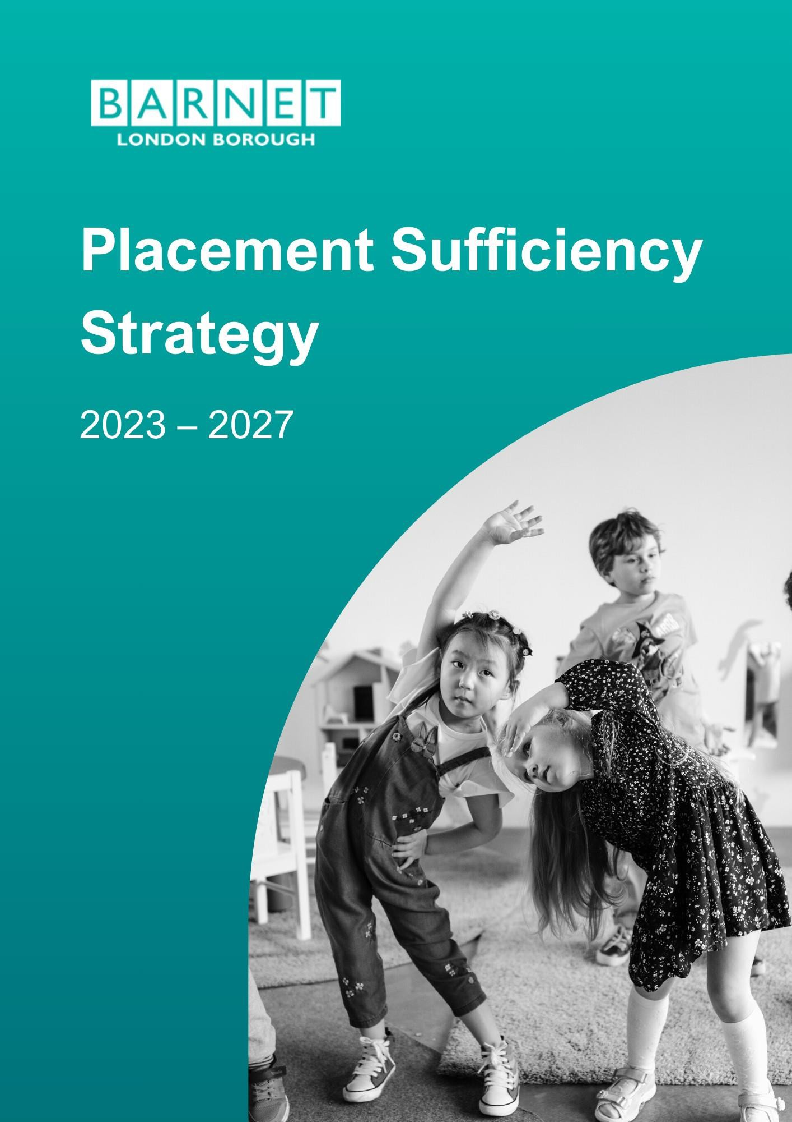

11

Placement Sufficiency Strategy
2023 – 2027

Directorate | Children & Family Services
Responsible Committee | Corporate Parenting Advisory Panel/Children and Young People Oversight and Scrutiny Committee
Review Date | September 2027

Contents
Foreword 4
Introduction 5
Section 1: How we work in Barnet 6
Listening to our children 6
Our practice: A family first approach 7
Our practice: A child focused approach to placement planning 7
Working together pan-London 8
Section 2: Progress Made Since 2019 9
Section 3: An Overview of our Children in Care Population 133
Priority 1: More Children Living Locally ........................................................................ 3434
Priority 2: More Children Living in Families 366
Priority 3: Sufficiency of High-Quality Supported Accommodation 377
Priority 4: Partnership 389
Priority 5: Data and insight 40
Priority 6: The Voice of Children 41
Annex 1: Pan-London Collaboration 42
Annex 2. Governance 44

Fore word
Our vision is for children and young people in Barnet to live their lives successfully with the right support. We want Barnet to be the best place in London to raise a child and for all children to thrive and achieve their potential – socially, emotionally, and academically.
Our ambition is to create a family-friendly borough, where children and young people’s rights are respected: a place where the voices, needs, priorities and rights of children are considered and taken seriously as an integral part of public policy, programmes and decision-making.
We will achieve this by delivering universal services that offer support, build resilience, and provide important protective factors. We also recognise the need to deliver high quality services for all our young people, particularly our most vulnerable, through close collaboration with our partners. We are committed to working together to secure the delivery of efficient, high quality and best value services.

“Resilient children thriving in resilient families living in resilient communities”.

In Barnet we want the same things for the children and young people in our care as any good parent would want for their child. Our Children and Young People Plan and Corporate Parenting Strategy support this aim and demonstrate how seriously the Council takes its responsibility as a Corporate Parent, focusing on our responsibility for our children in care and care experienced young people.
We want our children to be resilient; by that we mean to have a healthy and happy childhood, to feel valued and loved, and to have the chance to grow, develop and learn so that they become confident and independent adults. Ensuring that the borough has sufficient high-quality placements, accommodation, and support to meet the needs of all our children in care and care experienced young people is essential to support this ambition.
We focus on hearing the voice of our children and young people, safeguarding them from harm, supporting them to achieve positive outcomes and enabling them to achieve their aspirations and make a positive contribution.

Chris Munday, Executive Director of Children’s Services Cllr Pauline Coakley-Webb, Portfolio holder for Family Friendly Barnet

Intro duc tio n
In Barnet, we believe that for most children, the best place to live is with their families of origin. However, there are circumstances where some children need to live in alternative care arrangements. Barnet Council is the Corporate Parent for those in our care and we have high aspirations for our children. Our duty goes beyond the provision of safe placements for these children and requires us to do all that we can to ensure that they have the support and resources to achieve the best possible outcomes.

We have both a moral and legal duty to ensure, as far as it is practical, that there is sufficient accommodation for children in care within the local area and that we address any identified gaps in provision through robust plans and commissioning strategies. This duty is set out in Section 22G of the Children’s Act and was further outlined in statutory guidance issued by the Department for Education (2010)1.

This Sufficiency Strategy sets out how we will meet this duty and the steps we will take to secure sufficient accommodation for our children; providing them with the right placement at the right time which is of high quality and provides them with the love and support they need to achieve their full potential.

The Strategy sets out How we work in Barnet and the key corporate principles and priorities that inform and underpin what we do. It gives an update on the Progress made since 2019, which was when our last Sufficiency Strategy was published, and provides an Overview of our children in care, identifying key themes and challenges. Finally, it identifies our Key priorities for the next four years and actions that we will be taking to continue to ensure that we can source the right placements for our children and young people.

1 Securing sufficient accommodation for looked-after children, Department for Education (2010) sufficiency_ -
_statutory_guidance_on_securing_sufficient_accommodation_for_looked_after_children.pdf (publishing.service.gov.uk)

Sectio n 1: How we work i n Bar net
Our vision is for all children and young people in Barnet to live their lives successfully with the right support, as set out in our Children and Young People Plan 2023-20272.

As corporate parents for children in care and care experienced young people, we want the same things for our children and young people as any good parent would want for their child. We want our children and young people to have a healthy and happy childhood, to feel valued and loved, and to have the chance to grow, develop and learn so that they can find their own way in the world as successful and fulfilled adults.

Our Corporate Parenting Pledge sets out what our children and young people can expect from us. Adherence to this pledge informs how we work as a local authority and therefore underpins this Sufficiency Strategy.

Our Corporate Parenting Pledge
- We will support you to fulfil your dreams.
- We will be there for you, when you need us.
- We will support your mental and physical health.
- We will listen, communicate and make decisions together with you.
- We will support you to become independent and prepare for adulthood.
- We will celebrate children & young people, their achievements, identity and culture.

Listening to our children
It is important to us that we listen to our children who are in care, helping us to understand their lived experience so that we can continue to improve the services that support them.

As detailed in our My Say Matters Barnet Child Participation & Family Involvement Strategy 2022-253, we have a well-established Children in Care Council and a range of approaches to involving children and young people so they can tell us what they think, help us make decisions, and design and shape our services. This includes our new Young Commissioner Programme. We will continue to co-design future placement plans and initiatives to ensure children’s views are at the forefront of our work.

In addition to the above we also commission the Bright Spot Survey, which is a national project led by Coram Voice and the Rees Centre (Oxford University). This survey helps us to better understand the lived experience of our children in care and care leavers. It creates an opportunity for children and young people to tell us about the things that are important to them and what makes life good for them. The last survey took place in 2021 when 152 of our children in care (52%) and 116 care leavers (33%) submitted responses. We have commissioned another survey that will take place during the period of this Strategy.

The results from the 2021 survey were positive in highlighting that most of our children know and trust their social worker, feel involved in decisions made about their lives and feel safe where they live. It did though identify some areas for improvement which our

2 Strategy available online here
3 Document available online here. Further information available at www.barnet.gov.uk/mysaymatters

care leaver service is addressing, in collaboration with young people. This included the need for:
  - Stronger pathways for young people transitioning to leaving care services requiring support with their mental health.
  - Appropriate, safe and stable accommodation options available for young people moving to independent living.
  - All of our young people to develop the necessary life skills to support their transition into independent living.

Our practice: A family first approach
Our practice framework is about a ‘family first’ approach, supporting and developing resilience in families to remain together. We believe that individuals, families, and communities are capable of growth, learning, and positive change, and that they are experts on their own lives. Our approach fosters empowerment and self-determination, building resilience in families and communities by highlighting their strengths and placing them at the heart of our purpose.

When things go wrong within a family and the children are at risk or are suffering harm, we will in the first instance always work to keep a child within their family networks and create change through the child protection framework or using the legal framework of the pre-proceedings processes in the Public Law Outline.

When children are placed in care, we will regularly review the child’s care arrangement to ensure that they continue to meet the changing needs of children. Our ‘family first’ approach means that (where appropriate) we will always consider if children could be supported to return home, and what support children and families might need to enable this to happen.

Our practice: A child focused approach to placement planning
We recognise that not all children are able to remain with their parents or family networks and need to be safeguarded within alternative care arrangements. This Placement Sufficiency Strategy will ensure that for these children we have the right placement options which are in the right place, made at the right time and are of high quality. We recognise that stable, resilient, and supportive relationships are a key factor in improving outcomes for children and we achieve this through our practice and in securing safe and caring homes for our children. Through the effective implementation of our Placement Sufficiency Strategy and a child focused approach to identifying and monitoring placements and care planning we will work to deliver the following for children in care:
  - The individual needs of children will drive the placement planning process.
  - We will always look for our children to live locally and maintain connections with local communities.
  - We want all our children to be loved, feel safe and be encouraged to be the best that they can be.
  - We will take a holistic approach to placement planning, working with education and health partners to ensure children can access the support they need.
  - We will strive for placement stability and encourage children to maintain safe and secure relationships with friends, family, and other trusted adults.

  - We take a resilience-based approach and our independent living programme forms an integrated part of all living arrangement for children who are 16 years and over, to support a successful transition to adulthood.

Regulatory changes
Changes in the regulatory framework have had a big impact on the provider market in recent years. Since 2021 it has been unlawful to place a child under the age of 16 in any provision that is not regulated by Ofsted. This has led to increased demand for fostering and residential placements and has had an impact on placement availability. Evidence suggests the only use nationally of unregulated provision to meet the needs of extremely complex children is where there is a lack of regulated placements to meet their needs.

Since 28th October 2023, it is unlawful for a Local Authority to place children and young people aged 16-17 in any provision that is not registered with and regulated by Ofsted. Inspections for supported accommodation will commence from April 2024 under a new regulatory framework for this type of provision. As a Local Authority we are working to support providers through this change.

Working together pan-London
The pan-London Placements Commissioning Programme is a well-established programme of work with a focus on improving commissioning outcomes for the cohort of children in high-cost low incidence placements. The priorities for this workstream are set by the Association of London Directors of Children Services (ALDCS), with the work co- ordinated by the London Innovation and Improvement Alliance (LIIA). A monthly Commissioning Panel, with representation from each of the London sub-regions, oversees this work and ensures links are made with commissioning activity within each of the sub-regions.

London research has identified that therapeutic and specialist placements for vulnerable adolescents with high levels of need and complex need is in short supply and that local authorities struggle to source placements to meet the needs of this cohort. The focus of the programme is therefore building sufficiency for this cohort. There are also pragmatic reasons for this emphasis as commissioning support services for this cohort at a local authority level can be challenging given the small number of children and the variation in demand which makes forward planning problematic.

This pan-London work has also led to the incorporation of a Pan London Vehicle for Complex Children’s Commissioning (PLV). This is a risk-sharing vehicle for the commissioning of high-cost low incidence provision in London, including the planned Secure Children’s Home. It will be jointly owned by all London Local Authorities.

As this regional work continues to develop and grow in maturity, Barnet plans to work closely with other London authorities to commission services for young people with the most highly complex needs. The move to regional commissioning is also the direction of travel from the Department for Education with their planned development of Regional

Care Co-operatives, as outlined in the Independent Review of Children’s Social Care (MacAlister 2022)4.

Where it is prudent to do so, Barnet will look to work with regional partners to share costs, invest resources and deliver projects together. A full list of the pan-London projects and research papers is included in Annex 1.

Sectio n 2: Pr ogress Made Si nce 2019

This section provides a summary of our key priorities from our 2019-2023 Sufficiency Strategy and progress made against each of these priorities.

Priority | Progress
Further develop our edge of care offer | Parenting Hub - In 2021 we developed an innovative Parenting Hub to offer specialist and targeted parenting interventions for parents with complex emotional needs and their children aged 0-5. A total of 18 families (22 children) were supported between November 2021 and November 2023.  Reduction in use of residential care – There has been a reduction in the proportion of children that Barnet places in residential children’s homes, reducing from 15% in 2016/17 to 11% in 2021/22.  Investment in edge of care services. We have a comprehensive preventative Early Help offer, the REACH service for vulnerable young people and an innovative Youth Justice offer including diversionary and positive activities for young people at risk of exploitation. The edge of care worker is now embedded in the safeguarding teams.  We continue to convene Family Group Conferences, Family Network Meetings and multidisciplinary planning meetings to arrange the right support at the right time. A programme of training has been rolled out  across the entire children’s social care workforce to support our edge of care work in line with the presenting needs of our children and families.  Pan-London ASD/SEMH project. Pan-London project to deepen our understanding of this cohort of children and develop evidence-based commissioning solutions and practice guidance which prioritises prevention of avoidable crisis, and better support for children and young people who present in crisis at services across the system.
4 MacAlister, J (2022). The Independent Review of Children’s Social Care. Department for Education. [ONLINE] I ndependent rev iew of
c hildren's s oc ial c are - final report (publis hing.s erv ic e. gov. uk )

Our new Specialist Autism Team co-ordinates specialist assessments and care planning, coordinating multidisciplinary support to families. We are working with our health colleagues in our ICB to develop and embed Positive Behaviour Support approaches for children.

We have expanded the work of our Integrated Clinical Teams as a core part of our Early Help offer.
Grow in-house fostering capacity | More children are living in families. In 2021/22, 71% of all Barnet’s children in care were living with a family. This is an increase from 69% the previous year.  Growth in Connected Carers. Our in-house fostering team has supported more children to live with friends/family (i.e. Connected Carers) or with their parents, with numbers increasing by 100% between 2017 – 2022.  In-house placements static. Over the last two years the rate of in-house placements across London have fallen by 8.7% in real terms. Barnet, however, is performing relatively well in comparison to other London local authorities. Over the last three years Barnet has approved 45 new carers in comparison to the average approvals across the North London Consortium  of 31 carers (45 being the highest and 16 the lowest).  The number of in-house fostering placements has remained stable although the relative proportion of children within in-house fostering has reduced and like other Local Authorities, we have seen an increase in the need to use external fostering agencies to meet the needs of our children. Our in-house fostering provision now accounts for 27.6% of all placements.
Build and commission specialist residential provision in borough | Increased local residential supply. Since April 2022, we have repurposed one provision into a high needs, supported accommodation provision in line with local needs for young people aged 16+ and built and opened a new therapeutic 6 bed residential provision with onsite therapeutic support and clinical consultations to consider creative solutions for children with particular vulnerabilities and needs.  Overall residential placements within Barnet have grown by 21 spaces for children since 2021 and there are now a total of 32 beds within the Borough.  In addition, an in-house residential home is due to open in December 2023. This is a solo home that is designed to support children with highly complex needs. When open, this will increase total capacity to 33 beds.  Pan-London commissioning for children with highly complex needs. Barnet continues to work collaboratively on pan-London projects, including in

the development of a Secure Children’s Home in London and the London Accommodation Pathfinder, offering a local alternative to custody for young people involved within the youth justice system.
Development of the Creative Solutions Forum to meet the challenge of reduced residential respite. Since 2019, the number of specialist overnight respite units in London have reduced considerably. In response to these challenges, the Council has established a Creative Solutions Forum which identifies alternative support packages to help families and help children remain at home and prevent admission into care as a result of a safeguarding or mental health crisis.
Step Down. The Council’s residential ‘step down’ programme is well established. All transition planning puts children at the centre of care plan and we work proactively with providers to facilitate effective, planned placements moves when young people are ready. Working with our ‘My Say Matters’ programme, more work is planned to further develop a child focused best practice approach to transition, including step down.
Residential parenting assessment centres. We are part of a new pan London framework which aims to develop this type of provision and share best practice in the capital.
Accommodation and support offer for 16+ and care leavers | New regulation for supported accommodation: We are supporting our providers through the regulatory changes via positive relationships and utilise a strengths-based approach to referrals to support effective matching and positive placement outcomes. All providers used by Barnet to support looked after children have now registered successfully with Ofsted.  Quality assurance. Our semi-independent provisions continue to provide high quality local homes for young people as they develop independent living skills. Barnet has robust quality assurance mechanisms in place which has been adapted to the new Ofsted regulations.  Sufficiency of provision. Barnet has a sufficiency of local supported accommodation provision and our placement team has positive relationships with trusted local providers.  Increased accommodation options. Since 2021, we introduced a range of new pathway options for our care experienced young people to move on to. This year we have worked in partnership with Barnet Homes to ringfence additional homes for care experienced young people locally. As part of the Moving forward programme there is ring-fenced accommodation for 12 young people across two properties and Barnet Homes has surpassed their housing target by identifying properties and rehoused 55 young people in

22/23 and 62 so far during 23/24. 11 care leaver parents have been rehoused into 2 bedroomed homes and where they have vacated smaller properties these have been ring-fenced for care experienced young people.

Supported lodgings growth. We have established an in-house supported lodgings service. While relatively small (11 carers) it is growing, and we have ambitions to continue this growth.

Staying Put. We had a total of 49 Staying Put agreements across the year in 2022-23 and the number of young people in this arrangement type has increased slightly between 2019 and 2023.

UASC support. In response to the significant increase in numbers of UASC since 2019, we have developed a specialist multidisciplinary support offer and created a dedicated UASC team in our Leaving care service, Onwards and Upwards, to ensure a timely and joined up response to care planning for this cohort.
Commissioning Intentions | Regional Commissioning. We have mature regional commissioning arrangements and work with partners at both the sub-regional (Commissioning Alliance) and regional level (London) to deliver placements that meet the needs of our young people (see Annex 1 for examples of projects). Barnet also leads the Section 251 Project, which is a national project funded by the Department for Education to improve financial reporting in children’s services.  Quality Assurance. Quality assurance of placements takes place at both a local and regional level, through work with the Commissioning Alliance. A key priority has been focusing on quality assurance of supported accommodation in advance of regulation by Ofsted. Monitoring visits are completed to all residential placements to ensure quality of care and value for money.  Growth in local residential supply. There has been a 44% growth in local residential care provision between April 2022 and April 2023. This will rise to 48% when the new in-house solo residential home opening in December 2023.

Section 3: An Overview of our Children in Care Population

Before focusing on our key strategic priorities for the 2023-27 Sufficiency Strategy, this section provides some context about Barnet’s care population and identifies some of the key themes and trends. This is contextualised against pan-London data.

The majority of data in this section comes from the Dynamic Sufficiency Tool5. This is an innovative pan-London project, supported by Barnet, which has used anonymous placement data from across all 33 London councils to provide local authorities with meaningful insight to inform their commissioning strategies and sufficiency planning. This tool uses longitudinal data to highlight key themes and trends in the data, which may not otherwise be visible through analysis of snapshot data from a certain point in time.

The number of children in care each quarter is increasing, with the increase at a higher rate than the rest of London
Between January to March 2022, there were 431 children who experienced a period of being in care in Barnet. Since 2017/18, the increase in looked after children has continued but become more graduated. The growth in Barnet’s children in care population is increasing faster than the pan-London average. Over the period 2016 to
2022, Barnet’s care numbers increased by 25.2%, compared to 4.3% at the London level.

Fig 1: Percentage Change in the Care Population 2016-2022. Barnet vs London

Time Period | Barnet % Change | London % Change
20-21 Q4 to 21-22 Q4 | + 8.8% | + 2.2%
19-20 Q4 to 20-21 Q4 | + 2.3% | - 2.4%
18-19 Q4 to 19-20 Q4 | + 4.0% | + 2.7%
17-18 Q4 to 18-19 Q4 | - 0.2% | + 3.2%
16-17 Q4 to 17-18 Q4 | + 8.4% | -1.46%
2016 - 2022 | + 25.2% | + 4.3

5 Further information is available here: Pan-London Dynamic Sufficiency Tool – LIIA

Fig 2a: Barnet’s Care Population 2016-2022

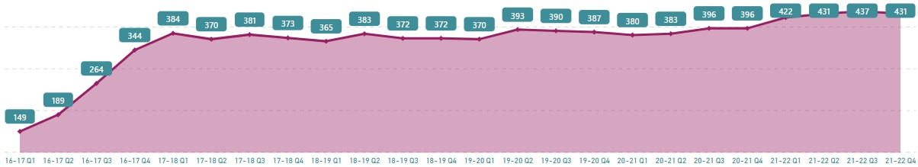

Fig 2b: London’s Care Population 2016-2022

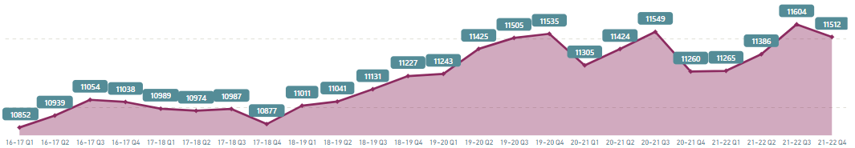

The growth in Barnet’s care population is driven in part by the growth in the number of Unaccompanied Asylum-Seeking Children (UASC). Figure 3a highlights that when excluding UASC from analysis the growth reduces to 20.8%. Irrespective of the UASC population, the number of children experiencing an episode in care in Barnet has been increasing and at a rate far above the London average; a trend which has been particularly apparent over the last 12 months. This trend is largely due to an increase in older adolescents entering care as a result of being held on remand, family breakdown as a result of poor mental wellbeing after the pandemic and in 2021/22 there were a number of larger sibling groups that came into care.

Figure 3a: Percentage Change in the Care Population 2016-2022. Barnet vs London (Excluding UASC)

Time Period | Barnet % Change | London % Change
20-21 Q4 to 21-22 Q4 | + 9.9% | + 0.06
19-20 Q4 to 20-21 Q4 | + 1.2% | + 1.7
18-19 Q4 to 19-20 Q4 | + 3.9% | + 1.7
17-19 Q4 to 18-19 Q4 | - 0.3% | + 1.3
16-17 Q4 to 17-18 Q4 | + 4.4% | - 1.2
2016 - 2022 | +20.8 | +3.7%

Fig 3b: Barnet’s Care Population 2016-2022 (excl. UASC)

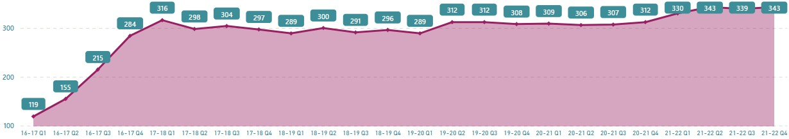

Fig 3c: London’s Care Population 2016-2022 (excl. UASC)

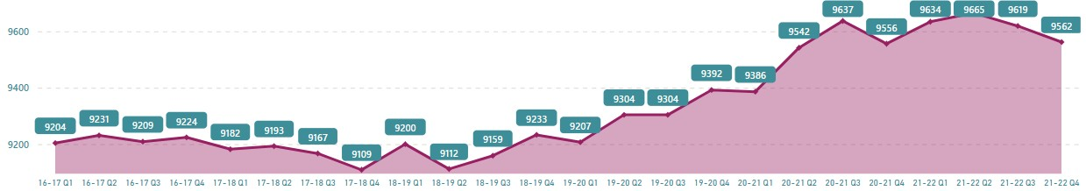

Vulnerable adolescents and children and young people with complex needs
Following a detailed review of our highest needs placements and where we have not been able to source placements locally, we do not currently have placement sufficiency for the following cohorts.

- Vulnerable adolescents - this includes children with behaviours that pose a risk to others; children that have experienced criminal exploitation; mental health or emotional difficulties; self-harm; suicidal ideation; children that go missing; and/ or children with a disability including neurodiversity.

- Parent and baby placements- while we have local provision and London based residential assessment centres, Barnet does not have any local fostering provision for parent and child placements. We have seen a significant increase in parent and child placements since 2016/17. Last year we had 22 Parent and Child Placements over the course a year, with 5-6 in placement at any one time. The gap has resulted in the exclusive use of external providers who are situated outside of the Barnet authority boundary and represent high-cost placements.

For our vulnerable adolescent cohort, these children benefit most from bespoke provision on an individual basis and ensuring that they have the right support considering their specific needs is key to promoting the best outcomes for them. The requirement is therapeutic placements, access to effective mental health support and high levels of placement stability. Some of these children would have a deprivation of liberty order.

Unaccompanied Asylum-Seeking Children (UASC) represent 20% of Barnet’s Care Population, which is above the pan-London average The number of asylum-seeking children increased significantly during the year 2016/17, with the increase from 30 to 60 children equivalent to a 100% rise. Since 2017/18, numbers have continued to increase but have done so broadly in-line with wider care
population and, as such, the relative proportion within the care population that are UASC has remained relatively constant.

Since 2019, we experienced an increase in referrals of Unaccompanied Asylum Seeking Children (UASC) from 5 Home Office Hotels established in the borough and the subsequent increase in care experienced young adults needing support.

Fig 4: Percentage of Barnet’s Care Population that are UASC

Year  (Q4 snapshot) | Number UASC | Total LAC Population | % LAC Population that are UASC
2021/22 | 88 | 431 | 20.4
2020/21 | 84 | 396 | 21.2
2019/20 | 79 | 387 | 20.4
2018/19 | 76 | 372 | 20.4
2017/18 | 76 | 373 | 20.4
2016/17 | 60 | 344 | 17.4

In comparison to London, a higher percentage of Barnet’s care population are UASC. In 2021/22, UASC made up 20.4% of Barnet’s care population, compared to the London average of 16.9%. Barnet’s UASC population has been gradually increasing in numbers since 2016/17, although the proportion of UASC have remained stable as a percentage of the total Barnet care population. In contrast, London’s UASC population has fluctuated significantly but has overall declined since 2019/20 in both real and percentage terms.
Since their 2019/20 peak, the number of UASC in London has fallen by 11%.

When comparing Barnet’s UASC population to the rest of London it is also apparent there are differences in demographics. For example, at the London level 33% of UASCs
identify as Black, compared to 17% in Barnet. London also has higher levels of children identifying as white (17.8% compared to 10% in Barnet). The largest ethnic grouping in Barnet (53%) is ‘other/unknown’ as their ethnicity does not fit within the classification used for this data. Figure 5 (below) provides further detail about Barnet’s UASC population.

Fig 5: Barnet’s UASC Care Population 2016-2022

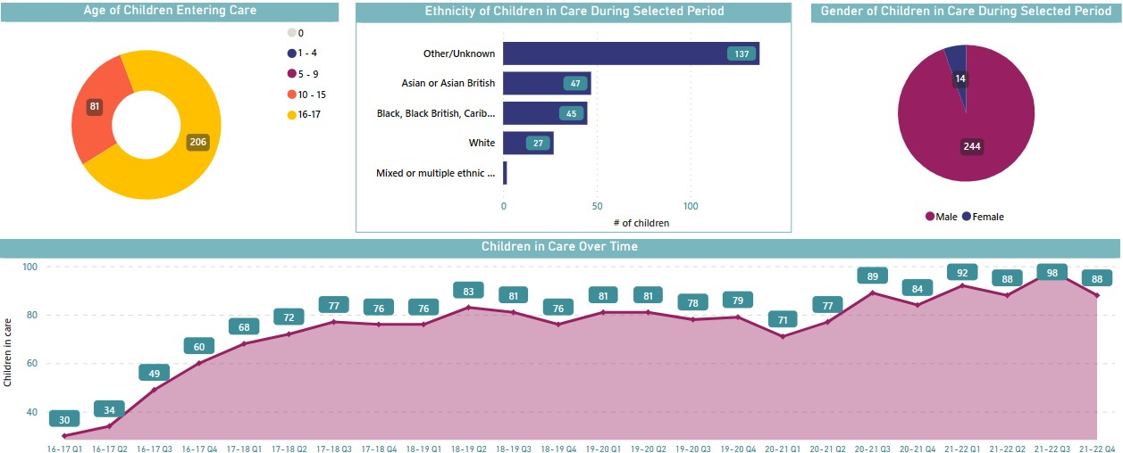

An increasing percentage of children from ethnic minorities
Most of the Barnet’s care population (65%) are from ethnic minorities, although white is the largest single ethnicity (35%). Over the last six years the percentage of children described as white has reduced by 7% and there has been a corresponding 7% increase in children described as ‘other’ or ‘unknown.’ Barnet has a far higher percentage of children described as ‘other/unknown’ than other London authorities (in 2021/22 this was 19% in Barnet compared to the pan-London average of 9%).

When comparing the ethnicity of Barnet’s children to the pan-London average, another key difference is that Barnet has a significantly smaller percentage of children that are black, black British, Caribbean or African. At a pan-London level this is the second largest cohort and represents 29% of all children, whereas in Barnet it accounts for only 19%.

Fig 6: Ethnicity of Barnet’s Care Population 2016-2022

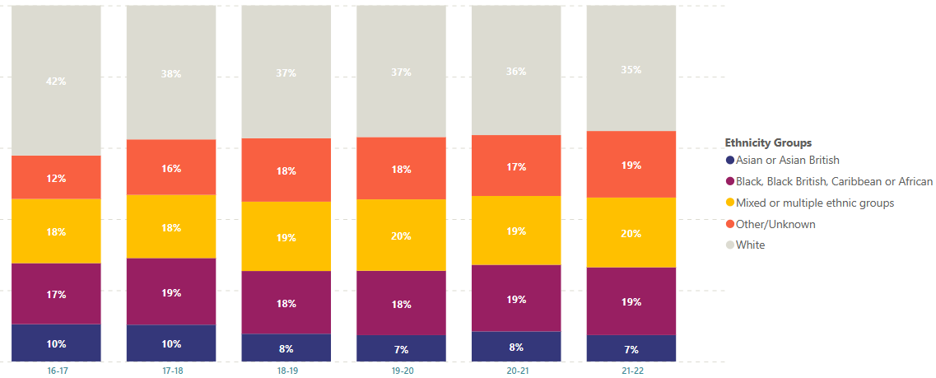

A high proportion of the care population enter care aged 16/17
During the period 2016-2022, 36.4% of the children that entered Barnet’s care were aged 16+. This is influenced by the relatively high number of UASC in Barnet, which is relevant given that a high number of UASC (typically 70%) enter care over the age of 16. When the cohort of UASC are removed from analysis, the percentage of children entering care in Barnet aged 16+ reduces to 27.1%.

In comparison with other London local authorities, Barnet has a slightly higher percentage of children entering care aged 16+. When UASC are included in analysis, the London average is 35.1%, and when they are excluded this drops to 25.9%.

Fig 6: Age Children entered Barnet’s Care 2016-2022

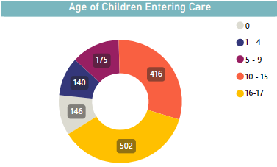

More children are living in family settings, with particular growth in Independent Fostering and Connected Carers.
In 2021/22, 71% of all Barnet’s children in care were living with a family. This represents a slight increase from the previous year when it accounted for 68.9% of all children, although slightly below the London average of 72.9%. While the total numbers of children living in family settings has remained relatively stable there are some key trends emerging:

1) Increase in Connected Carers and children that are being supported to live with parents. During 2021/22, this cohort increased by 14%.

- Increase in fostering placements from the Independent Sector. Since 2016, there has been a year-on-year increase in the number of children living with foster families from the independent sector. Over the last 12 months the number of placements has increase by 28%. In this period, the relative proportion of the care population living in independent fostering has also increased, rising from 25.2% to 29.4%. In line with London sufficiency trends for fostering, we have increasingly relied on placements in the independent sector specifically to keep sibling groups together, for parent and child placements and children with profound disabilities. This growth is highlighted in Figure 6a below.

Fig 6a: Barnet’s Growing Utilisation of IFA placements 2016-2022

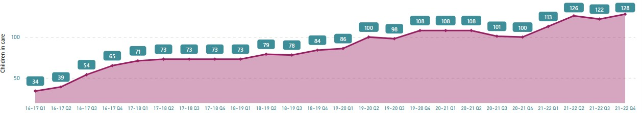

- Stable in-house fostering numbers for the last two years. The number of children living with in-house foster carers peaked in the year 2018/19, fell in 2019/20 and has remained relatively stable since. While numbers have remained stable the relative proportion of children living with in-house carers has been reducing year-on-year: 37.6% in 2018/19; 31.3% in 2019/20; 30.3% in 2021/22 to 27.6% in 2021/22.

Fig 6b: Barnet’s in-house fostering placements 2016-2022

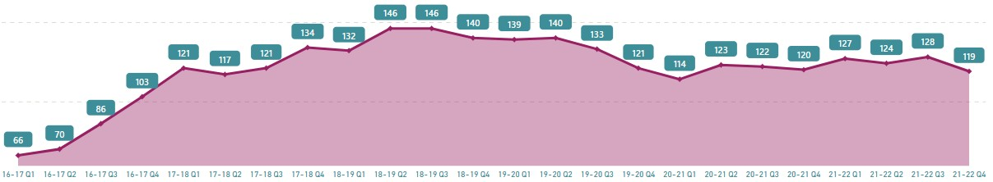

The above graph highlights that while Barnet’s in-house fostering placements have reduced significantly since their peak in Q2 of 2018, there has been relative stability over the last two-year period. In comparison, there has at the London level been a year-on- year reduction in the number of in-house fostering placements since 2016. Over the last

two years the number of London placements reduced by 8.7%. The performance of Barnet’s in-house fostering should therefore be taken in this context (see table below). Figure 6c: Percentage change in in-house fostering placements. London vs Barnet.
(using snapshot data in Q4 of each year)

Year | Barnet | London
20/21 to 21/22 | - 0.8% | - 2.8%
19/20 to 20/21 | - 0.8% | - 6.4%
18/19 to 19/20 | - 13.6% | - 1.6%
17/18 to 18/19 | + 4.3% | - 0.3%
16/17 to 17/18 | + 30.1% | - 4.3%

The relative percentage of the care population that are living with in-house fosters carers is reducing in both Barnet and London. At the end of 2022, 27.6% of Barnet’s care population were in in-house fostering placements which was in-line with the London average of 27.8%.

Figure 6c: Decline in the number of in-house fostering placements pan-London 2016 -2022

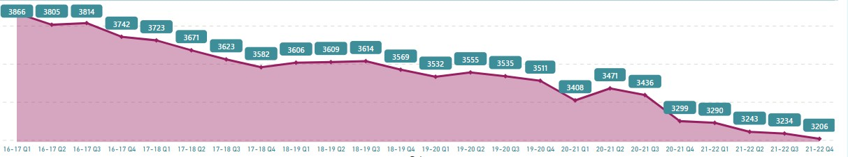

Reduction in the percentage of children in residential care
There has been a reduction in the proportion of children that Barnet places in residential children’s homes, reducing from 15% in 2016/17 to 11% in 2021/22. This reduction has brought Barnet much closer to the London average of 9%. In real terms, the number of children placed in residential care has remained relatively stable, fluctuating around 100 placements per annum (or circa 70 unique children). These numbers have though remained stable in the context of growing numbers of children in care, which has led to a

reduction in the relative percentage. The percentage of children in different placement types (at both the London and Barnet level) is set out in Figures 7a and 7b below:
Over 2018-2022, the proportion of residential placements with external providers has increased from its lowest figure of 47% in 2019 to 55% in 2022. This trend, reflecting an increased reliance on external provision is reflected in other Local Authorities across London and is due to multiple factors including the complex needs of some of our vulnerable adolescents.

Fig 7: Barnet’s Placement Type (%) 2016-2022

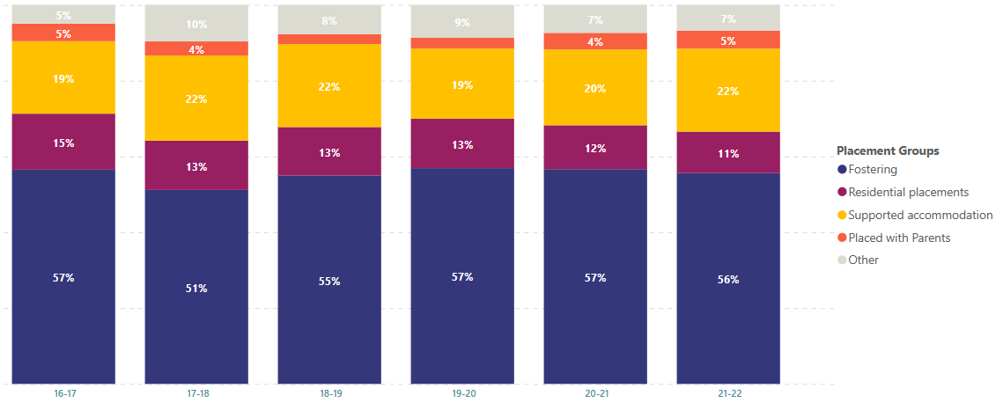

Fig 7b: London Placement Type (%) 2016-2022

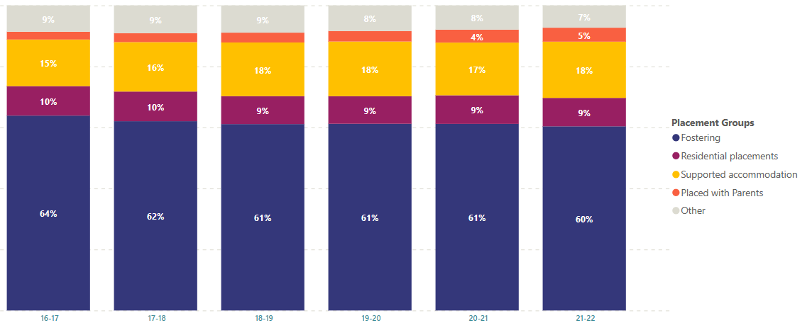

High Utilisation of supported accommodation, with particularly high representation from Unaccompanied Asylum-Seeking Children Barnet places a slightly higher percentage of its children in supported accommodation (see figure 7a/7b) than other London authorities. In 2021/22 this accounted for 22% of Barnet’s care population, compared with 18% at the London level. Whilst this is not
significantly higher percentage than the London average it is notable as it is a trend that was present every year between 2016-2022. This is in part due to the relatively high number of UASCs in Barnet (see figure 4) given that this cohort of children are more likely to be aged 16/17 and living in supported accommodation. However, excluding this cohort Barnet’s utilisation of supported accommodation is consistently just above the London average.

Barnet places a higher percentage of its UASC in supported accommodation, compared with other London authorities. In 2021/2, 58% of Barnet’s UASCs were in supported accommodation compared to 51% at the London level. Other London authorities are more likely than Barnet to place UASC in fostering placements. At the London level 46% of UASCs are placed in foster care, compared with 38% in Barnet. This information is shown in figures 8a and 8b below.

Fig 8: Placement Type (%) for Barnet’s UASC population 2016-2022

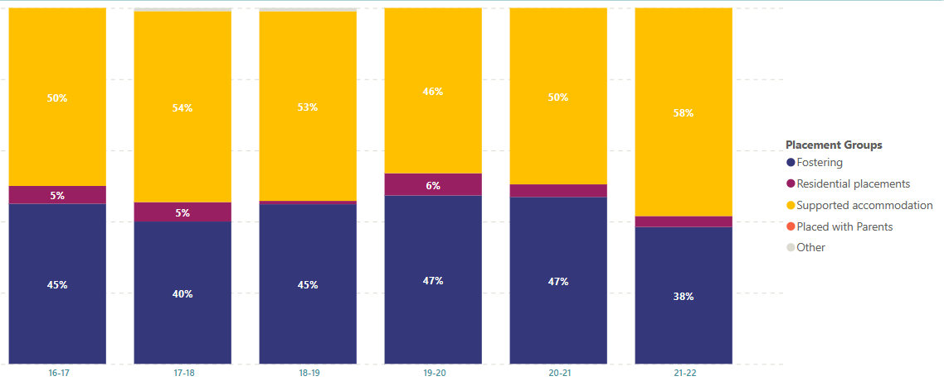

Fig 8b: Placement Type (%) for London’s UASC population 2016-2022

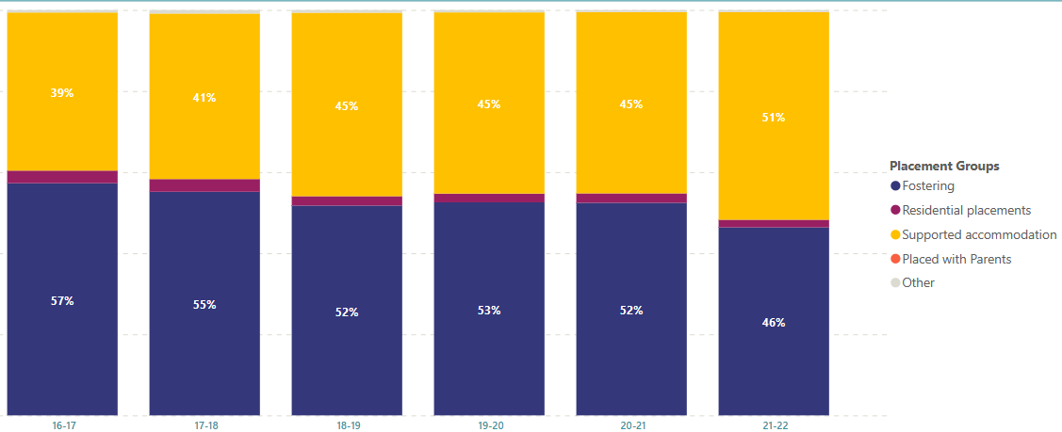

A lack of residential care provision, despite a significant increase in local supply
As of April 2023, there are seven registered children’s homes within the Borough of Barnet, with a combined total capacity of 32 beds. Since April 2022, four new registered homes have been set up within the Borough, which has increased supply by 21beds. The increase in residential provision, driven in part by Barnet’s investment in its own 6 bed residential children’s home, is at a far greater rate than the rest of London. In the same time period London’s bed numbers increased by 4.5% (802 in April 22 to 838 in April 23).

Figure 9: Residential Children’s Home Capacity in Barnet as of November ‘23

 | Sector | Capacity
Home 1 | Local Authority | 6*
Home 2 | Local Authority | 6
Home 3 | Private Sector | 2
Home 4* | Private Sector | 5*
Home 5 | Private Sector | 5*
Home 6 | Private Sector | 3
Home 7 | Private Sector | 4*
- Indicates it is a new provision set up in 2022

In addition to the above, a new one bedded in-house residential children’s home is due to open in December 2023. This will be able to accommodate children with highly complex needs. This will increase capacity to 37 beds and will mean that from April 2022 capacity will have increased by 48%.

Despite this growth in provision there are still insufficient residential children’s home placements within the Borough. For example, in the last quarter of 2021/22 there were 45 Barnet children living in residential care. There are similar sufficiency challenges across London. In the last quarter of 2021/22 London authorities collectively made 1088 residential care placements, which was 231 more than the total number of beds in the capital.

Across London the shortfall in residential provision is exacerbated by the limited utilisation of residential provision that does exists. In 2021/22, only 56.7% of London based residential capacity was utilised by London authorities, with the remaining 43.3% either void or filled by a non-London local authority. On average, London authorities only utilised 24.7% of the provision within their own geographical boundaries. Barnet has a higher utilisation rate than the rest of London, which means it makes better use of the provision that exists locally. In 2021/22, Barnet utilised 35.1% of potential local capacity with 27.2% used by other London authorities. This does though still leave 37.7% of capacity which is not being used by London and is either void or filled by non-London authorities.

Without access to data from non-London local authorities it is not possible to understand how much of this unused capacity is void and how much of it is taken by other authorities. Research undertaken by the Commissioning Alliance (2020), found similar levels of unused capacity and identified that 26% of unused provision was filled by non-London authorities with the remainder vacant. A small percentage of vacant beds (7%) were described by providers as unavailable, but 67% were vacancies that providers confirmed could accommodate children.

Research undertaken by the NCB (2022) 6 further explored the low utilisation rate of residential care in London with recommendations which included the need to develop closer relationships with local providers; the need to challenge commissioning and social work practice and develop a deeper understanding of the provider landscape by placement type, along with further information sharing with providers regarding the needs of London’s children and types of provision required to meet these needs.

Figure 9a: Utilisation of Residential Provision within Barnet 2017-2022

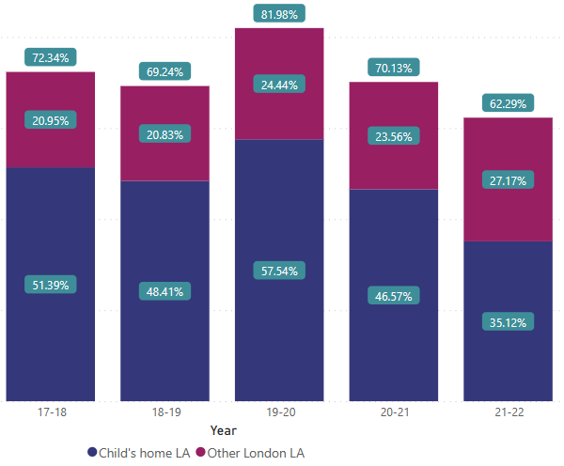
Figure 9b: Utilisation of Residential Provision across London 2017-2022

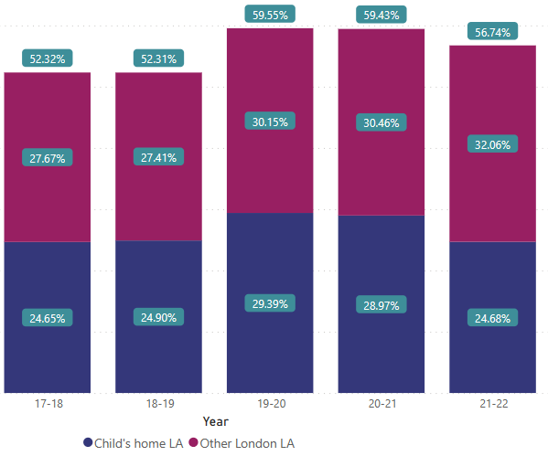

6 London-Children-London-Lives-Research-into-Under-Utilisation-8.pdf (liia.london)

*In the above graphs, blue denotes the extent to which a local authority maximises provision within their own geography. The red shows the extent to which London authorities collectively utilise the provision within the geography. For example, in 2021/22 Barnet used 35.12% of the total residential capacity within its own geography. An additional 27.17% of the provision within the geography of Barnet was used by other London authorities. This accounted for 62.29% of total capacity and therefore 37.71% is unaccounted for. It can be assumed that this provision is either filled by a non-London local authority or vacant.

More local residential placements, but when children are placed out of area they live further away.
A lack of therapeutic, residential provision that can meet complex needs within Barnet (and London more generally) means that Barnet uses residential provision that is outside of London. Furthermore, these children tend to be placed quite a large distance from Barnet. In 2021/22, 50% of all residential care placements were made more than 20 miles away from a child’s home. This rose to 78% when in-house provision was excluded. This is higher than the London average where 42% of children are placed more than 20 miles from home.

Barnet does though have a significantly above average percentage of children in residential care that are placed within the Borough (34% in 2021/22 compared to the London average of 19%). It can be concluded therefore that in comparison to other London authorities, Barnet is more successful in finding local residential placements but that when children are placed out of area they are more likely to live over 20 miles away from home than children from other London authorities.

The geographically dispersed nature of residential care placements is shown in the map below:

Figure 10: Location of all Barnet’s Residential Care Placements 2016-2022

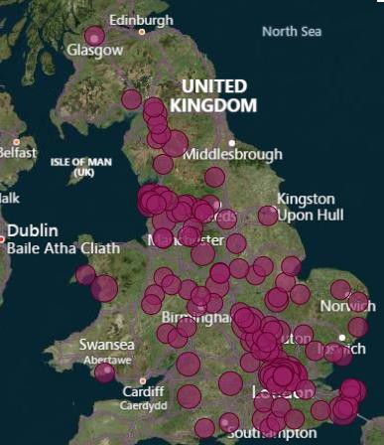

High number of different residential care settings
Since 2016/17, Barnet has made 381 residential care placements to support 183 individual children. These children have been supported across 138 different residential children’s homes. This pattern of commissioning, working with lots of different providers, is common across the whole of London. Accordingly, for many of the providers that work with London, the percentage of their service that support London children is limited. In 2021/22, 57% of the residential providers that London placed with had less than 20% of their total capacity filled by London authorities. Indeed, 22.5% of providers London had placements with had less than 10% of their provision used by London authorities.

From the perspective of a local authority there are both benefits and challenges of having a large provider base. A challenge might be developing meaningful relationships with a wide number of different providers, many of whom may only have one young person from the authority. Indeed, research undertaken by the NCB (2022) into underutilisation made the recommendation that authorities across London work to develop more meaningful relationships with local providers.

The number of unique residential settings that Barnet uses each year is set out below:
  - 2018/19 - 49 unique providers
  - 2019/20 - 51 unique providers
  - 2020/21 - 51 unique providers
- 2021/22 - 42 unique providers

More children are living locally
Despite challenges with residential sufficiency, and the high percentage of out of area residential placements the overall percentage of all children in care to Barnet placed within the borough is increasing. In 2021/22, 40% of all children lived within the Borough, which was an increase from 33% the previous year. Compared to other London authorities, more of Barnet’s children are placed within Borough. However, as per the section on out of area residential placements above, when Barnet makes out of area placements children appear to live a long way from their homes with a relatively high proportion of children living in the North of England and the Midlands.

Figure 11: Geographical Location of Placements made by Barnet Council 2016-2022

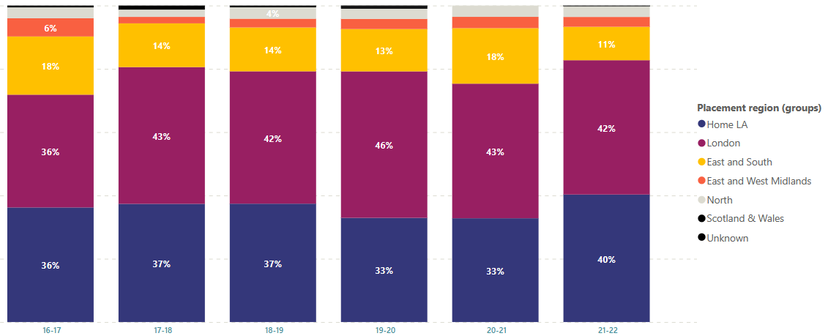

Figure 11b: Geographical Location of Placements made by London authorities 2016-2022

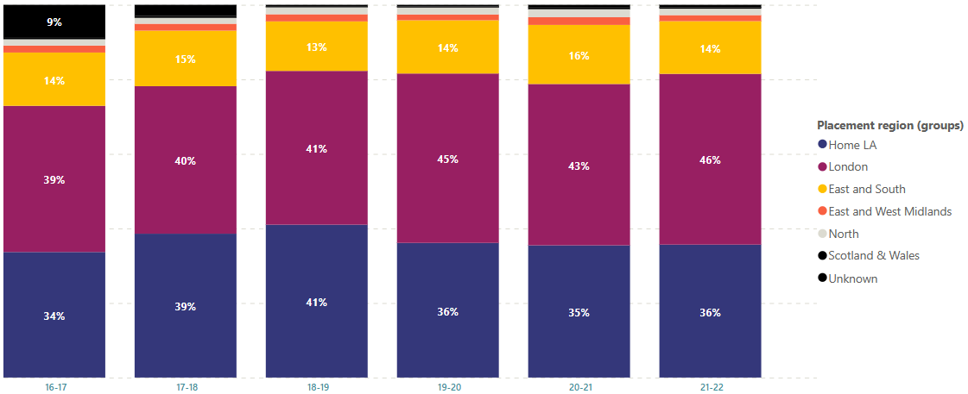

Lack of Residential Secure Provision and Growing Demand for DOLs There are no Residential Secure Homes in London and as such all young people placed in secure are inevitably separated from their families and support services. On average these young people are placed 192 miles from their local authority7. In 2020/21, 61 children from London were placed in out of area Residential Secure Homes. Snapshot

7 Pan London Snapshot 2020

data shows (see figure 12) that over the last two years there are approximately 34 London children in secure provision at any one time.

Figure 12a: Number of children in Residential Secure 2018 -2022

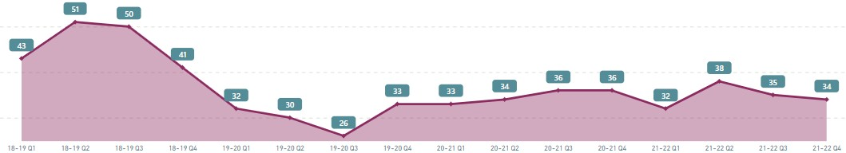

The number of secure placements made by Barnet has remained consistently low. The lack of secure beds available has resulted in Barnet making use of solo placements with intensive wrap around support to manage the complex behaviours of a small group of children.

Given that demand for secure far outweighs supply, the number of London children in secure may not necessarily reflect demand but instead the availability of national provision – which will largely be dependent on which other young people nationally are at the time also requiring support.

To understand demand for Secure Homes, it is important to contextualise this with the increasing demand nationally for Deprivation of Liberty (DOL) orders. Research undertaken by Nuffield (2023) highlights that DOL orders are increasing and now far exceed the number of secure accommodation applications (see Fig 12). A DOL order authorises the deprivation of a child’s liberty in a setting that is not otherwise authorised to do so. As such, it can be assumed a lack of secure provision is one of the key contributing factors to an increase in DOL orders (see Nuffield 2023:11). Accordingly, to understand true demand for residential secure provision this needs to be seen in the context of the number of DOL applications (see fig 9 below).

Over the last three years Barnet has seen a significant increase in the number of children in placements that have DOLs orders. There have been six placements with DOL orders in 2023-24 to date.

Fig 12b: National number of DoL and secure accommodation applications July 2022 to March 2023

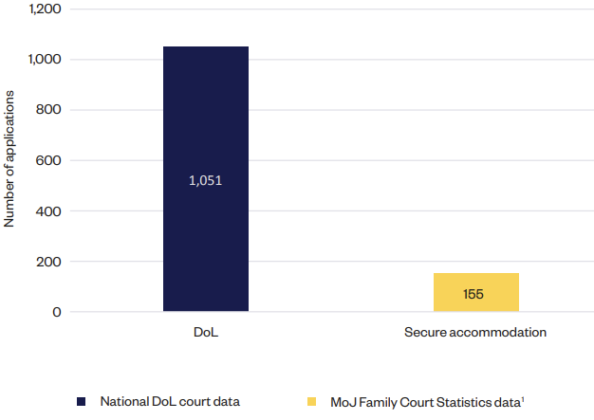
Graph taken from Nuffield (2023:9)8

Forecasting a stable care population, but increasing numbers of placements
Figures 1 and 2 (above) show that each quarter there are a growing number of placements that are being made by Barnet. However, our snapshot data shows that the number of children who are in care at any one time at the end of each financial year has remained relatively stable. This is shown in figure 13 below.

A stable population of children in care but a growing number of care placements, suggests that there may be an increasing number of short-term care placements and/or children that are in care for a shorter period. This trend is largely the result of UASCs entering care at 17+ and will move to 18+ accommodation relatively quickly from time of entry into care.

There has also been a number of adolescents who have returned home after a short period in care. Ongoing work is taking place to develop intensive support to prevent children from entering into care and to ensure children in Tier 4 units are able to return home on discharge with the necessary package of support.

8 Available online here

Figure 13: Snapshot data showing children in Barnet’s Care 2016-23

Year | Children in care on 31st March
2016-17 | 343
2017-18 | 328
2018-19 | 311
2019-20 | 327
2020-21 | 329
2021-22 | 333
2022-23 | 332

We have forecast the number of children in care (using the Monte Carlo analytical method) and we expect that the total numbers of children in care based on concurrent snapshot data will remain static into 2024/25.

Priority 1: More Children Living Locally

We have made significant progress increasing the number of our children who can be supported to live locally. In 2021/22, 40% of our children in care were able to live within the Borough. While this is a significant improvement on previous years, and above the London average, we know we must continue to do more. Our key priority will therefore be to increase both the number and overall percentage of children in care that live within the boundaries of Barnet.
Placing our children locally enables Barnet children to access the comprehensive support we have in place for them, including specialist mental health services and bespoke support for our UASCs. It also offers a wealth of other benefits such as maintaining local connections, employment opportunities, housing, health and education, friendship, faith, and cultural support. This creates resilience in our young people.
Challenges remain in finding appropriate placements that meet the needs of children and young people with specific vulnerabilities such as autism, and social, emotional, and mental health needs including trauma, exploitation and children with disabilities. This trend has been observed across London, with significant shortfalls in provision within our local provider landscape.

How will we do it?
- Grow local residential provision. Since April ’22, residential provision within Barnet has grown but we know this is still insufficient. We will look to further increase the number of residential homes within the Borough. We have developed a business case to explore creating additional in-house small residential home provision. We will also continue to work with the independent sector, encouraging investment within the Borough.
- Increase utilisation of local residential provision. While Barnet utilises a greater proportion of local residential capacity than other London authorities, we know a significant proportion of provision (64.88% in 2021/22) is not being used by the authority. We will commit to work to the recommendations set out in the NCB (2022) 9 research paper, including developing closer working relationships with local providers, and rethinking commissioning approaches to foster growth in local sufficiency that meet the needs of our children in care
- Connected Carers. We know that children living with connected carers (i.e. friends or family) are very likely to live locally and can provide a loving family environment for our children. Where it is appropriate to do so and provides the best outcomes for our children we will continue to support these placements. Significant progress has already been made and between 2019 and 2022, the percentage of placements increased by 122%.
- Out of area residential placements closer to Barnet. We know that we have made significant progress keeping children local but that when we do place out of area we typically place a long way from Barnet. For the vast majority of children we will always look to place locally but we know for a small cohort their needs a such that they require specialist out of area provision. For this cohort we will

9 London-Children-London-Lives-Research-into-Under-Utilisation-8.pdf (liia.london)

explore how we can develop relationships with specialist out of area providers that are geographically closer to Barnet.
- Grow in-house fostering. We will continue to recruit and train in-house foster carers. We know this will be challenging and that across London the number of in- house foster carers are reducing. To support this work, we have commissioned research which identifies strengths and areas for improvement in our current recruitment and retention and explores opportunities for innovation.
- Develop local provision to support parent & child placements: During 2022/23 Barnet made 22 Parent and Child Placements. Currently Barnet does not have any in house fostering or assessment unit provisions for parent and child placements and that has resulted in the exclusive use of external providers who are situated outside of the geography of Barnet. We will explore ways in which we can increase the number of foster carers who are able to offer care for this cohort, through both recruitment and training.
- Continue work with other London authorities to develop provision for young people with the most highly complex needs. We recognise that there is a need for more provision to support children with highly complex needs. For this cohort it often makes sense to commission provision at a London level. Barnet will continue to work with London to support this cohort. Key projects include:
  - London Accommodation Pathfinder: We will continue to support this pathfinder project which provides accommodation for children on remand as a practical alternative to custody.
  - Secure Children’s Home: We will continue to support the pan-London project (funded by the Department for Education) to open a new Residential Secure Children’s Home in London by 2026.
c. PLV: We will continue to support the development of the Pan London Vehicle for Complex Children’s Commissioning (PLV). This is a risk-sharing vehicle for the commissioning of high-cost low incidence provision in London, including the planned Secure Children’s Home. It will be owned by all London authorities.

What will success look like?
- Further increase the number of residential beds within the Borough.
- Increased utilisation of local residential provision
- A reduction in both the number and percentage of children placed in out of area residential care.
- An increase in the number of children living with in-house foster carers and Connected Carers.
- Specialist provision within London that can support young people with highly complex needs (including a Residential Secure Home and the London Accommodation Pathfinder).
- Increased local provision for parent and child assessments to enable more of our children to remain in Borough and access local support.

Priority 2: More Children Living in Families

For the majority of our children in care, the best place for them to live is in a loving family environment. Over the last twelve months we have made progress with the percentage of children living within families increasing to 71% but we know there is more for us to do.

How will we do it?
- Connected Carers. We know that many children will benefit from living with a family which is already part of their family network. Since 2019, the percentage of Connected Carer placements has increased by 122%. We will continue to prioritise these arrangements wherever possible.
- Support to families. We will further develop our out of hours service that responds to families at risk of breakdown and provide mediation, interventions and activities based on assessed needs to keep children at home where safe and possible to do so.
- Support to children and families at the edge of care. We will continue to commission and facilitate Family Group Conferences, Family Network Meeting and multidisciplinary creative solution forums which develop plans for children at the edge of care, supporting children to stay at home wherever this is possible and to plan transitions back to family, where it is safe to do so.
- Continued investment in our Specialist Autism Service. We will continue investment in our autism service, providing children and families with the multidisciplinary support they need to help children live at home.
- Grow in-house fostering. We will continue to recruit and train in-house foster carers. We know this will be challenging and that across London the number of in- house foster carers are reducing. To support this work, we will commission research which identifies strengths and areas for improvement in our current recruitment and retention and explores opportunities for innovation.
- Supported Lodgings. We will increase the number of supported lodgings carers in the Borough, with a focus on growing our new in-house service. This will provide family options for young people in supported accommodation.

What will success look like?
- An increase in the number of children living with in-house foster carers/connected carers.
- Maintain our investment in edge of care services so that more children can be supported to live with their families.
- More young people matched to supported lodgings carers in the Borough

Priority 3: Sufficiency of High-Quality Supported Accommodation
We consistently support 20% our children in supported accommodation and we anticipate that demand will continue. Historically, this sector has been unregulated but from October 2023 it has been overseen by Ofsted. While registration should raise standards it may have unintended consequences, including a reduction in supply and increased costs (see Newton: 2023)10. We will ensure that there continues to be a sufficiency of high quality and local provision which meets the needs of our young people.

How will we do it?
Deepen our understanding of the sector. Regulation by Ofsted will significantly increase the availability of data which will enable us to develop a more comprehensive understanding of supply. Building on existing pan-London analytical tools, we will use this data to monitor sufficiency and underpin more evidence-based commissioning practice.

Supported Accommodation Commissioning Plan Building on the availability of more data about this market, we will develop a specific Supported Accommodation Commissioning plan to share with our providers. It is anticipated this could include activity to inform our providers on what we need more of and our requirements in line with the new regulations; support established supported accommodation providers to develop residential children’s homes and deliver both sufficiency and value for money through local block contracting arrangements.

Partnership. We will work with local supported accommodation providers, helping them to raise their quality, in line with the regulations and in accordance with the needs of our children, ensuring young people are supported to develop the skills to thrive and go on to live independently.

Quality Assurance. It is important that we continue to quality assure all supported accommodation provision, but we recognise our approach will need to be updated to reflect the new role of Ofsted. Working with Ofsted, providers, the Commissioning Alliance and other local authority partners we will develop a proportionate and complementary approach to quality assurance.

What will success look like?
- Maintain the sufficiency of supported accommodation provision within Barnet to ensure better placement choice
- All provision supporting our children is regulated, with the accommodation quality assured
- Close working relationships with local supported accommodation providers, supporting them with continuous improvement.
- Our young people feel confident in their independent living skills and equipped to move on to greater independence.

10 Newton (2023), Demand and Capacity of Homes for Children in Care [online] Newt on-Demand-and-Capac ity -of -Homes -f or-
Children-in-Care. pdf (c ounty c ouncils net work . org. uk )

Priority 4: Partnershi p
We recognise that the challenges faced by local authorities trying to secure a sufficiency of high-quality care provision are significant. This is highlighted in recent national reports, including: the Children’s Social Care Market Study (Competition and Marketing Authority 2022)11 and the Independent Review of Children’s Social Care (MacAlister 2022)12. This challenge is exacerbated by increasing cost pressures for local authorities. In 2021/22, local authorities spent £11.9bn nationally on children services, with 137 local authorities (91%) reporting that they were overbudget13.

We will further develop the positive working relationships between our placements team, Commissioning and placement providers with the objective of improving their capacity for providing placements for our young people with significant vulnerabilities and complex needs.
We work proactively on a sub regional and pan London level to influence and shape the provider landscape at scale. By working together, we believe we are more likely to be able to deliver a sufficiency of provision, especially for meeting the needs of our children with highly complex needs; share expertise and best practice; and also share the costs of investment and any financial risks associated with creating new provision.
We will prioritise working together to commission high cost; low incidence provision, namely: therapeutic placements, trauma-informed support, child centred positive behaviour support, solo and small provisions that include multidisciplinary wrap around support.

How will we do it?
We will continue to work with London to develop the following services:
- London Accommodation Pathfinder: Support continuation and extension of this pathfinder, acting as a practical alternative to custody.
- Pan London Autism and Mental Health project (ASC SEMH) : which focuses on the needs of children with high needs Autism and Mental Health who are at risk of hospital admission/ re-admission.
- Secure Children’s Home: Support the development of this project to open a new Residential Secure Children’s Home in London by 2026.
- Pan London Vehicle: We will continue to support the development of this Pan London risk-sharing vehicle for the commissioning of high-cost low incidence provision in London.
- Pan London Framework for Residential Assessment Centres. We support the development of the pan-London procurement Framework for Residential Assessment Centres and plan to commission all our residential assessments through this procurement.

11 Children's social care market study final report - GOV.UK (www.gov.uk)
12 MacAlister, J (2022). The Independent Review of Children’s Social Care. Department for Education. Available here
13 Section 251 Financial Return to the Department for Education 2021/22

- Dynamic Sufficiency Tool. We will continue to support the development of this innovative pan-London analytics tool.

What will success look like?
- Barnet will continue to be a key partner, supporting an effective regional commissioning function which delivers projects that require scale to be effective.
- Specialist provision is established within London, supporting young people with highly complex needs. This will include a Residential Secure Home and the further development of the London Accommodation Pathfinder project.
- Barnet will deliver value for money by working in partnership with other local authorities (i.e. shared investment cost and sharing any financial risks associated with large scale invest-to-save development projects).

Priority 5: Data and i nsight
For a Sufficiency Strategy and subsequent commissioning activity to be effective, it needs to be informed by a robust evidence based. Data is essential to ensure we understand:
- Current need and future trends in demand
- Supply and the extent to which it meets the need of current/future demand
- The impact of our intervention and progress we are making against our strategy
- What additional activity is required by us to inform our commissioning activity
Building on well-established analytical tools that have been developed collectively by London local authorities, we will continue to champion the importance of data and commit to developing commissioning strategies which are targeted and evidence-based to deliver the best possible outcomes for children.

How will we do it?
Pan London Investment: We will continue to work with other local authorities in London, sharing the costs of investment in analytics. Through this partnership we plan to extend our analytical tools to deepen our understanding of the supported accommodation sector (utilising the data which will now be provided by Ofsted) as well as data on usage of Deprivation of Liberty Orders (DOLs)
Supported Accommodation Insight: Building on the recommendations of Newton (2023), we will closely monitor the sufficiency of local Supported Accommodation throughout 2024, given the heightened risk of unplanned market exit following regulation. If there are emerging pressures with sufficiency, we will ensure we act swiftly to address issues and ensure a sufficiency of provision.
Publish Data to support care planning in local market: A key aspect of effective market shaping is ‘providing accurate and credible signals of the likely and future needs of children to existing and potential providers’ (CMA 2022)14. Barnet holds a significant amount of data about our current and future demands. We commit to publish data to support our local care providers to plan their services to meet our needs.
Forecasting: Working with pan-London we will build a forecasting model into our shared analytical tools to help us better understand future need at both a local and regional level.

What will success look like?
- Barnet will publish an online Market Position Statement, which provides current and prospective suppliers with information about current and future demand.
- Deepen our understanding of the local supported accommodation market.
- Pan-London data function which provides increasing level of insight to support local and regional Commissioning practice. This will include, but is not limited to, new insight on (i) use of Deprivation of Liberty Orders and (ii) the newly regulated supported accommodation market.

14 Children's social care study - GOV.UK (www.gov.uk)

Priority 6: The Voice of Childre n
We know that in order for us to develop provision that meets the needs of our children, we need to ensure that we engage with our young people and take their views into account in our commissioning practice.

How will we do it?
My Say Matters. As detailed in our My Say Matters: Barnet Child Participation & Family Involvement Strategy 2022-2515, we have a well-established Children in Care Council and a range of approaches to involve children and young people so they can tell us what they think, help us make decisions, and shape our services. We will continue to invest in this important work as set out in this strategy document.

Recommission Bright Spots Survey. In 2021 we commissioned the Bright Spots Survey, in partnership with Coram Voice and the Rees Centre, to help us better understand the lived experience of children in care and care leavers. We commit to recommissioning this survey during the period of this Sufficiency Strategy. This will help us to further understand the lived experiences of our children and young people.
Repeating the survey will also enable us to assess how views have changed over time and help us to determine what we doing well and what we could do better.

Young Commissioners. We are proud of our new Young Commissioner’s programme16. We will continue to invest in it and explore how the role can be expanded, including the role of this group in helping us to quality assure supported accommodation provision.

What will success look like?
- The views and lived experience of our children and young people informs our practice.
- Our children and young people in care feel like their views matter and that we listen to them.
- Our practitioners and providers know what matters most to our young people and how we get things right.
- Quantitative and qualitative data which helps us understand what we are doing well, how we compare to other regions and what we could be doing even better.

15 Available online here
16 Further information available online here

Anne x 1: Pa n-London Collabor ation

Regional Commissioning Projects
The below are a list of the key Children’s Commissioning projects that are being led through the pan-London Placement Commissioning Panel.

London Accommodation Pathfinder | London Accommodation Pathfinders have open in the North and East sub-regions of London, delivering 12 Supported Accommodation beds for children on remand across 13 local authorities. This innovative solution provides a practical alternative to custody. Plans are in progress to explore further expansion of the project across London.
Secure Children’s Home | Project to open a Secure Children’s Home in London by 2026. This project is being funded by the Department for Education.
Residential Parenting Assessments | A Pan-London procurement framework to support local authorities across London to procure Residential Parenting Assessments. Option for London to call-off a subsequent block contract.
ASD SEMH | The focus of this project is on the needs of children with high needs Autism and Mental Health who are at risk of hospital admission/ re-admission.

Pan-London Research Projects
A summary of published pan-London projects, which inform the work of the pan-London Commissioning Panel:

Review of Sufficiency Strategies in London Suh & Holmes (2020) | A review of London local authority sufficiency strategies undertaken by the Rees Centre at Oxford University. This study sought to provide a summary of existing placement sufficiency and sustainability initiatives across the capital, with recommendations to inform the development of a new approach, focusing on high- cost low-incidence placements.
Demand and capacity for Homes for Children in Care  Newton (2023) | Research which considered the impact of forthcoming regulation on the Supported Accommodation market. The recommendation was made that local authorities should undertake further work to understand the drivers for increasing demand. The research also identified a significant cohort of young people whose needs would be better served in independent housing and recommended action to address this to deliver better outcomes and reduce cost.
London children, London Lives: Understanding under-utilisation of London’s residential provision by London children  NCB (2022) | This research reinforced some of the key findings of the Complex Adolescents research, focusing on high numbers of out of area placements and limited utilisation of local provision. The paper considered some of the commissioning and social work practices that may contribute to out of area placements and put forward recommendations to increase utilisation of local residential provision.

Collaborative Commissioning, Creative Support

NCB (2022)
Project sought to better understand the needs of and provision for children and young people with Autism, a Learning Disability and/or Social, Emotional and Mental Health (SEMH) who are also Looked After Children or at risk of significant family breakdown and/or unplanned hospital admission. It is particularly pertinent considering the financial challenges that high-cost low incidence (HCLI) needs are creating for local authorities.

A key recommendation was the need to develop a comprehensive data dashboard containing data across education, health and care to underpin development of regional and ICS level strategy across London.

Anne x 2. Gover nance

Children and Young People Oversight and Scrutiny

Cabinet

For decisions and sign off that require cabinet approval, CPAP can report to the Children and Young People Oversight and Scrutiny for recommendations that are fed back to the panel.
Corporate Parenting Advisory Panel (CPAP)
Some decisions require final sign-off from cabinet, and CPAP may bring these decisions to cabinet in light of any recommendations made by oversight and scrutiny.

SLT provides senior sign off, feedback and recommendations to the Placements Board and MTFS, and sets the priorities for these forums.

Senior Leadership Team (SLT)

London Innovation and Improvement Alliance (LIIA)
LIIA are working on pan-London placement programmes led by Barnet’s Executive Director of Children and Families in his capacity as ADCS National Chair for Resources and Strategy
They report to CPAP on decisions made
around children’s social care placements.

Medium Term Financial Savings Group (MTFS)

This placement sufficiency strategy and the priorities within it will inform the Placements Board Action plan, which will be the main vehicle through which our progress towards our outcomes will be logged and measured. This board is chaired by Barnet’s Executive Director of Children and Family Services.

Placements Board
The MTFS group monitor the funding, expenditure forecast, savings and income generation for Family Services. In relation to corporate parenting projects and activities, they work closely with the placements board to ensure that these are aligned with the medium-
term financial strategy.

