

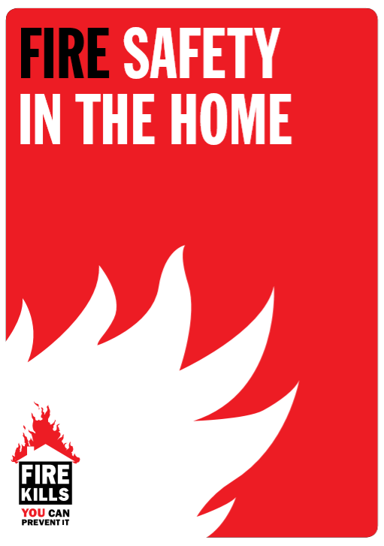

**FIRE IN THE HOME EVACUATION PLAN**

This fire evacuation plan is designed to ensure the safety of the family

**If a fire is discovered,** we have all agreed that we will phone the Fire Brigade



**Dial 999**

**ESCAPE ROUTES FROM EACH ROOM**

**PLEASE LIST IDENTIFIED ESCAPE ROUTES**

**The family will all meet in ……………………………**

**and exit the house by either route 1**

**……………………………………………………**

**or route 2**

**……………………………………………………**

When we have all exited the building, we will go to our **fire assembly point**

**……………………………………………………**

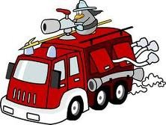

**We will not go back into the house until told to do so by the fire service.**

**We will practice our fire plan at least once a year or if our family circumstances change.**

**Date Completed : ……………………………………………………**

**Completed By: ……………………………………………………**

